Superlative form of adjectives
VY_22_INOVACE_03-54

Ročník: | 7.
Vzdělávací oblast: | Jazyk a jazyková komunikace
Vzdělávací obor: | Anglický jazyk
Tematický okruh: | Gramatika
Téma: | Superlative form of adjectives – 3. stupeň přídavných jmen
Jméno autora: | Mgr. Pavlína Vlková
Vytvořeno dne: | 7. listopadu 2011
Metodický popis,  (anotace): | Pracovní list slouží k procvičení stupňování přídavných jmen. Vysvětlen je zejména 3. stupeň („-est/most/irregular adj.“). Žáci doplňují tabulku „adjective-comparative-superlative“, následuje porovnávání zvířat podle obrázků („than/of all“).

Superlative form of adjectives (3. stupeň přídavných jmen)
smallest
shortest
longest
quickest
saddest
biggest
hottest
happiest
small
short
long
quick
sad
big
hot
happy

short adjectives

+ est

most beautiful
most expensive
most boring
most comfortable
most intelligent

beautiful
expensive
boring
comfortable
intelligent

long adjectives
most +

best
worst
furthest
good/well
bad
far
irregular adjectives

1) Complete the table with: adjective – comparative – superlative.
ADJECTIVE | COMPARATIVE | SUPERLATIVE
nice
 | taller
 |  | biggest
 | more beautiful
 |  | coldest
 | better
happy
 |  | worst

2) Complete the sentences, use the comparative or superlative form of adjectives:
than [ðən] = než
of all = ze všech
There are 3 boys – Adam, Ben and John.
Adam is tall. Ben is .................... than John.
Adam is ................. than Ben. Adam is the ................... of all.

3) Look at the pictures, complete the sentences – use adjective, comparative and superlative.
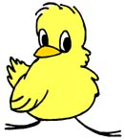 | 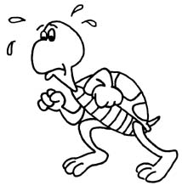 | 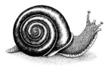 | A chick is slow .  A tortoise is slower than the chick.  A snail is the slowest of all. | slow
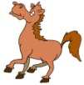 | 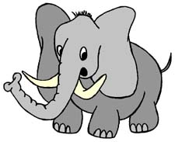 | 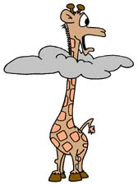 | A horse ....................................................  An elephant ............................................  A giraffe ................................................. | tall
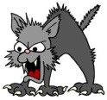 | 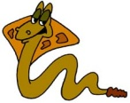  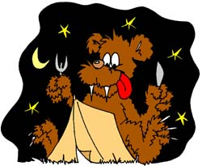 |  | ..................................................................  ..................................................................  .................................................................. | dangerous
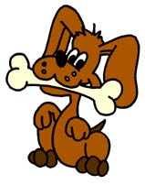 | 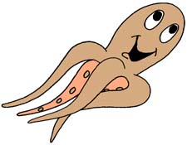  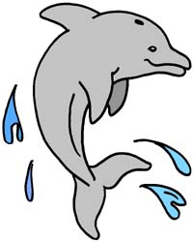 |  | ..................................................................  ..................................................................  .................................................................. | clever
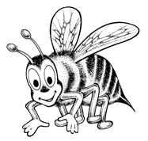  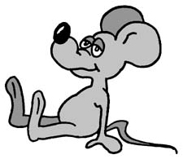 | 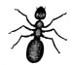 |  | ..................................................................  ..................................................................  .................................................................. | small
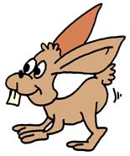 | 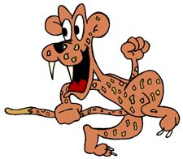  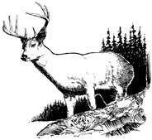 |  | ..................................................................  ..................................................................  .................................................................. | fast
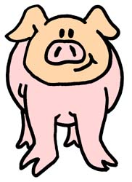 | 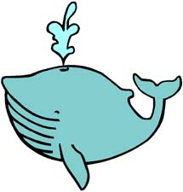  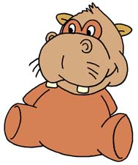 |  | ..................................................................  ..................................................................  .................................................................. | fat
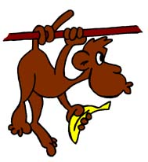 | 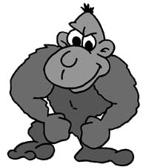  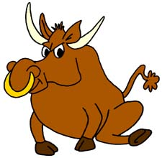 |  | ..................................................................  ..................................................................  .................................................................. | strong
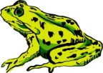 | 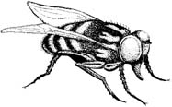 | 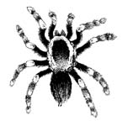 | ..................................................................  ..................................................................  .................................................................. | ugly
HELP: bull, hippo, fly, octopus, cobra, tarantula, cheetah, rabbit, dolphin, frog, bear,
ant, bee, mouse, monkey, gorilla, pig, deer, dog, cat, whale
Pokyny:
Pracovní list slouží k procvičení stupňování přídavných jmen. Vysvětlen je zejména 3. stupeň („-est/most/irregular adj.“). Žáci doplňují tabulku „adjective-comparative-superlative“, následuje porovnávání zvířat podle obrázků („than/of all“).

1) Complete the table with: adjective – comparative – superlative.
ADJECTIVE | COMPARATIVE | SUPERLATIVE
nice | nicer | nicest
tall | taller | tallest
big | bigger | biggest
beautiful | more beautiful | most beautiful
cold | colder | coldest
good | better | best
happy | happier | happiest
bad | worse | worst

2) Complete the sentences, use the comparative or superlative form of adjectives:
than [ðən] = než
of all = ze všech
There are 3 boys – Adam, Ben and John.
Adam is tall. Ben is taller than John.
Adam is taller than Ben. Adam is the tallest of all.

3) Look at the pictures, complete the sentences – use adjective, comparative and superlative.
 |  |  | A chick is slow .  A tortoise is slower than the chick.  A snail is the slowest of all. | slow
 |  |  | A horse is tall.  An elephant is taller than the horse.  A giraffe is the tallest of all. | tall
 |  |  | A cat is dangerous.  A cobra is more dangerous than the cat.  A bear is the most dangerous of all. | dangerous
 |  |  | A dog is clever.  A dolphin is cleverer than the dog.  An octopus is the cleverest of all. | clever
 |  |  | A mouse is small.  A bee is smaller than the mouse.  An ant is the smallest of all. | small
 |  |  | A rabbit is fast.  Deer is faster than the rabbit.  A cheetah is the fastest of all. | fast
 |  |  | A pig is fat.  A hippo is fatter than the pig.  A whale is the fattest of all. | fat
 |  |  | A monkey is strong.  A bull is stronger than the monkey.  A gorilla is the strongest of all. | strong
 |  |  | A frog is ugly.  A fly is uglier than the frog.  A tarantula is the ugliest of all. | ugly
HELP: bull, hippo, fly, octopus, cobra, tarantula, cheetah, rabbit, dolphin, frog, bear,
ant, bee, mouse, monkey, gorilla, pig, deer, dog, cat, whale

