Some x Any x A/An
VY_22_INOVACE_03-56

Ročník: | 7.
Vzdělávací oblast: | Jazyk a jazyková komunikace
Vzdělávací obor: | Anglický jazyk
Tematický okruh: | Gramatika
Téma: | Some x Any x A/An
Jméno autora: | Mgr. Pavlína Vlková
Vytvořeno dne: | 26. listopadu 2011
Metodický popis,  (anotace): | Materiál slouží k procvičení neurčitých členů a/an/some/any při slovní zásobě „jídlo“. Žáci se naučí rozlišovat použití členů u počitatelných a nepočitatelných podstatných jmen v kladné větě, záporné větě a v otázce. Nakonec používají členy v praktickém cvičení při popisu obrázků.

Some x Any x A/An
There is a banana. / There is an orange.
+
+
?
-
?
-
singular
?
-
+
There is some bread.
Is there any bread?
There isn't any bread.
Are there any bananas? / Are there any oranges?
There aren't any bananas. / There aren't any oranges.
There are some bananas. / There are some oranges.
Is there a banana? / Is there an orange?
There isn't a banana. / There isn't an orange.

COUNTABLE NOUNS

plural

UNCOUNTABLE NOUNS

Would you like some coffee? (offer)
Can I have some popcorn, please? (request)

2) Fill in some, any, a, an.
- Give me ............ lemon, please.
- Is there ............ milk?
- There aren't ........... apples.
- Have you got ........... butter?
- We haven't got .............. butter.
- Mike, are there .............. eggs?
- Can I have ............. tea, please?
- Let´s make ............ apple pie!
- Would you like ........... cup of tea?
- There are ........... hamburgers.
- There isn't .............. tomato.
- There isn't .............. water.
- Would you like ............ sugar in your coffee?
1) Write a/an or some.

........... grapes ........... carrot
........... orange ........... oranges
........... eggs ........... water
........... apple ........... banana
........... rice ........... butter
........... bread ........... sausage
........... tea ........... tomatoes
........... bananas ........... cherries
........... milk ........... meat
........... peach ........... sugar
........... coffee ........... lemons
........... salt ........... apricot
........... spaghetti ........... cheese

3) Write short sentences about the pictures, answer the questions.
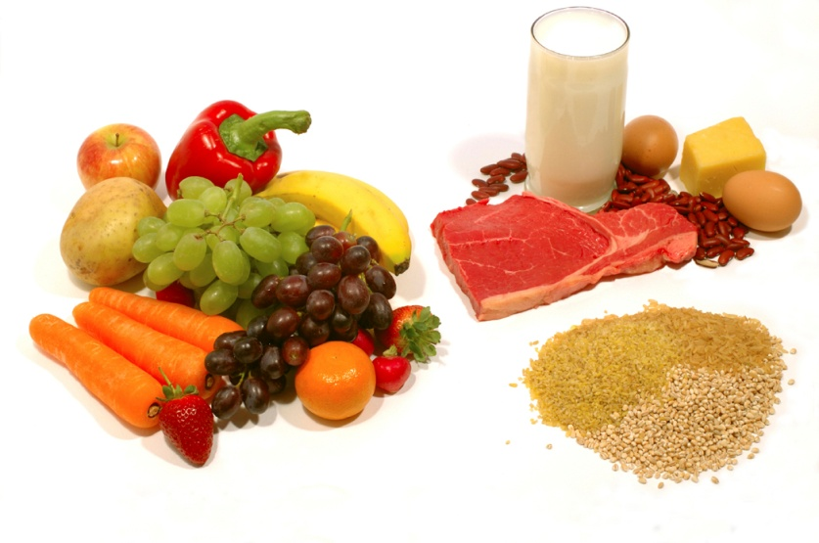
1
There are some carrots.
There isn't any water, there is some milk.

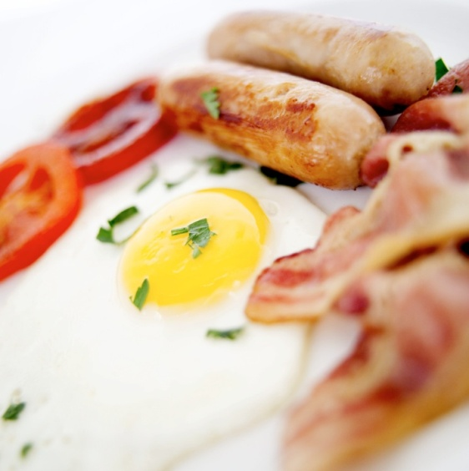
There is some bacon.
2

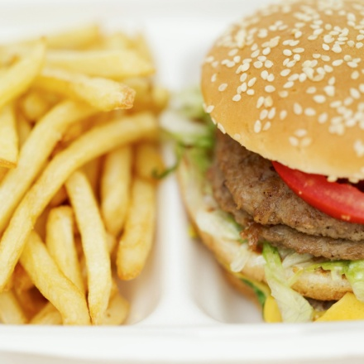
Are there any potatoes? –
3
Is there a tomato? –
Is there any lettuce? -
What else is in the picture?

Použité obrázky: www.office.microsoft.com [online]. c2011 [cit. 2011-11-26].

Pokyny:
Materiál slouží k procvičení neurčitých členů a/an/some/any při slovní zásobě „jídlo“. Žáci se naučí rozlišovat použití členů u počitatelných a nepočitatelných podstatných jmen v kladné větě, záporné větě a v otázce. Nakonec používají členy v praktickém cvičení při popisu obrázků.
Řešení:
1) Write a/an or some.
some grapes a carrot
an orange an oranges
some eggs some water
an apple a banana
some rice some butter
some bread a sausage
some tea some tomatoes
some bananas some cherries
some milk some meat
a peach some sugar
some coffee some lemons
some salt an apricot
some spaghetti some cheese

2) Fill in some, any, a, an.
- Give me a lemon, please.
- Is there any milk?
- There aren't any apples.
- Have you got any butter?
- We haven't got any butter.
- Mike, are there any eggs?
- Can I have some tea, please?
- Let´s make an apple pie!
- Would you like a cup of tea?
- There are some hamburgers.
- There isn't a tomato.
- There isn't any water.
- Would you like some sugar in your coffee?

3) Write short sentences about the pictures, answer the questions.
1) There is some meat. There is an apple.
There are some eggs. There is a potato.
There is some rice. There is a red pepper.
There are some beans. There is a banana.
There are some grapes. There are some strawberries.
There is a mandarin.
- “any” – záleží na fantazii žáků co není na obrázku
2) There is an egg. 3) Are there any potatoes? – No, there aren't.
There are some tomatoes. Is there a tomato? – Yes, there is.
There are some sausages. Is there any lettuce? – Yes, there is.
There are some chips.
There is a hamburger.
There is some meat.

