Present continuous - affirmative
VY_22_INOVACE_03-58

Ročník: | 7.
Vzdělávací oblast: | Jazyk a jazyková komunikace
Vzdělávací obor: | Anglický jazyk
Tematický okruh: | Gramatika
Téma: | Present continuous – affirmative; Přítomný čas průběhový – kladný tvar
Jméno autora: | Mgr. Pavlína Vlková
Vytvořeno dne: | 27. listopadu 2011
Metodický popis,  (anotace): | Materiál slouží k procvičení přítomného času průběhového –kladného tvaru ve všech osobách. Důraz je kladen na procvičení sloves s příponou –ing.

PRESENT CONTINUOUS – přítomný čas průběhový
AFFIRMATIVE – kladný tvar
SHORT FORM
I'm playing
you're playing

he
she 's playing
it

we
you 're playing
they
LONG FORM
I am playing
you are playing

he
she is playing
it

we
you are playing
they

+
run → running
swim → swimming
sit → sitting

make → making
take → taking
drive → driving

play → playing
go → going
watch → watching

verb + -ing

PRESENT CONTINUOUS: now / at the moment / at present

1) Write the verbs into the correct box.
take – sing – stop – begin – brush – give – ask – cut – eat – shop – shine – work – sit – leave – come – play – run – drive – go – swim – ride

+ ing | -e + ing | 2x consonant + ing

2) Complete the sentences, use present continuous.
- He ...................................... (brush) his teeth at the moment.
- I ......................................... (sit) in front of the computer now.
- Where is mum? – She ................................... (talk) on the phone.
- What is the weather like? – The sun .................................... (shine)!
- What are the children doing now? – They .............................. (play) football.
- It is very cold. I ................................ (wear) a scarf and gloves.
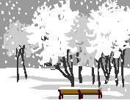
3) Look at the pictures. What is the weather like at the moment?
It .............................. The wind ................................
(snow) (blow)

The sun ........................ It ....................................
(shine) (rain)

4) Look at the pictures. Say, what are the people doing at the moment?
2
4
3
1



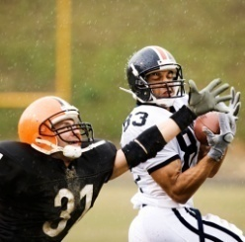
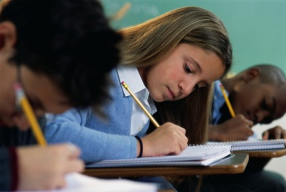







8
7
6
5

12
11
10
9

Použité obrázky: www.office.microsoft.com [online]. c2011 [cit. 2011-11-27].

Pokyny:
Materiál slouží k procvičení přítomného času průběhového –kladného tvaru ve všech osobách. Důraz je kladen na procvičení sloves s příponou –ing.

Řešení:
1)
+ ing | -e + ing | 2x consonant + ing
singing | taking | stopping
brushing | giving | beginning
asking | shining | cutting
eating | leaving | shopping
working | coming | sitting
playing | driving | running
going | riding | swimming

2)
- He is brushing (brush) his teeth at the moment.
- I am sitting (sit) in front of the computer now.
- Where is mum? – She is talking (talk) on the phone.
- What is the weather like? – The sun is shining (shine)!
- What are the children doing now? – They are playing (play) football.
- It is very cold. I am wearing (wear) a scarf and gloves.

3)
It is snowing. The wind is blowing.
The sun is shining. It is raining.

4) Alternativa k obrázkům: Co mají na sobě?
- He is crying. (What are they wearing at the moment?)
- He is skiing.
- They are playing rugby.
- He is riding a bike.
- They are dancing.
- They are running.
- They are taking a photo.
- They are reading a book.
- He is talking/calling/phoning/taking notes.
- She is driving a car.
- They are writing a test.
- She is swimming/diving.

