Present continuous - interrogative
VY_22_INOVACE_03-60

Ročník: | 7.
Vzdělávací oblast: | Jazyk a jazyková komunikace
Vzdělávací obor: | Anglický jazyk
Tematický okruh: | Gramatika
Téma: | Present continuous – interrogative; Přítomný čas průběhový – otázka
Jméno autora: | Mgr. Pavlína Vlková
Vytvořeno dne: | 2. prosince 2011
Metodický popis,  (anotace): | Materiál slouží k procvičení otázek v přítomném čase průběhovém. Zároveň se žáci naučí používat krátké odpovědi na otázky.

PRESENT CONTINUOUS – přítomný čas průběhový
INTERROGATIVE – otázka
SHORT ANSWERS
Yes, I am. / No, I’m not.
Yes, you are. / No, you aren’t.

he he
Yes, she is. / No, she isn’t.
it it

we we
Yes, you are. / No, you aren’t.
they they
INTERROGATIVE
Am I playing?
Are you playing?

he
Is she playing?
it

we
Are you playing?
they

+

1) Write „Am/Is/Are“ to the questions. 2) Write the infinitive of the verbs.
- .............. she cleaning the windows? → clean
- .............. you watering the plants? →
- .............. they playing basketball at the moment? →
- .............. we having lunch now? →
- .............. I asking right? →
- .............. Timmy flying a kite? →
- .............. John and Sam listening to the radio? →
- .............. you drinking coffee or tea now? →

3) Make questions and short answers in present continuous.
- (she / clean her teeth? – Yes)
A:
B:
- (they / walk a dog? – No)
A:
B:
- (you / cook dinner? – Yes)
A:
B:
4) Write the question to the picture, then answer.
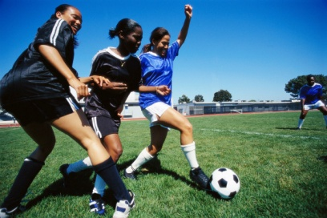
1. (play tennis)
A: Are they playing tennis?
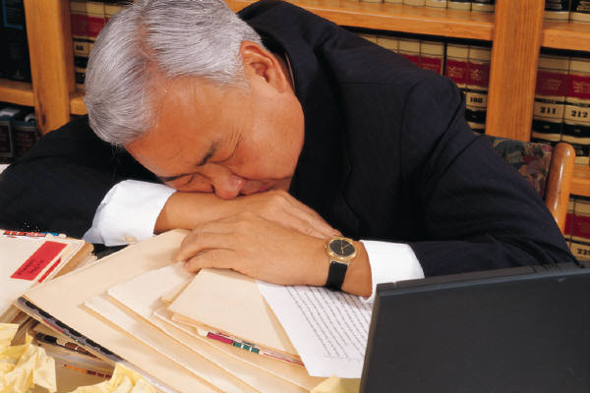
B: No, they aren’t. They are playing football.

2. (work hard)
A:



B:

3. (have lunch)
A:
B:


4. (drive a car)
A:
B:

5. (play with the dolls)
A:
B:

6. (teach physical education)
A:
B:

Použité obrázky: www.office.microsoft.com [online]. c2011 [cit. 2011-12-02].
Pokyny:
Materiál slouží k procvičení otázek v přítomném čase průběhovém. Zároveň se žáci naučí používat krátké odpovědi na otázky.

Řešení:
1) Write „Am/Is/Are“ to the questions. 2) Write the infinitive of the verbs.
- Is she cleaning the windows? → clean
- Are you watering the plants? → water
- Are they playing basketball at the moment? → play
- Are we having lunch now? → have
- Am I asking right? → ask
- Is Timmy flying a kite? → fly
- Are John and Sam listening to the radio? → listen
- Are you drinking coffee or tea now? → drink

3) Make questions and short answers in present continuous.
- (she / clean her teeth? – Yes)
A: Is she cleaning her teeth?
B: Yes, she is.
- (they / walk a dog? – No)
A: Are they walking a dog?
B: No, they aren’t.
- (you / cook dinner? – Yes)
A: Are you cooking dinner?
B: Yes, I am.

4) Write the question to the picture, then answer.
1. (play tennis)
A: Are they playing tennis?
B: No, they aren’t. They are playing football.
2. (work hard)
A: Is he working hard?
B: No, he isn’t. He is sleeping.
3. (have lunch)
A: Are they having lunch?
B: No, they aren’t. They are having coffee.
4. (drive a car)
A: Is he driving a car?
B: No, he isn’t. He is riding a motorcycle.
5. (play with the dolls)
A: Is she playing with the dolls?
B: No, she isn’t. She is playing with the cubes.
6. (teach physical education)
A: Is he teaching physical education?
B: No, he isn’t. He is teaching chemistry.

