Present simple - interrogative
VY_22_INOVACE_03-47

Ročník: | 6.
Vzdělávací oblast: | Jazyk a jazyková komunikace
Vzdělávací obor: | Anglický jazyk
Tematický okruh: | Gramatika
Téma: | Present simple – interrogative; Přítomný čas prostý – otázka
Jméno autora: | Mgr. Pavlína Vlková
Vytvořeno dne: | 26. října 2011
Metodický popis,  (anotace): | Materiál seznamuje žáky s použitím pomocných sloves „do“ a „does“ v otázce v přítomném čase prostém a s krátkou odpovědí. Po úvodním seznámení následuje krátké doplňovací cvičení. Druhá strana pracovního listu obsahuje poslechové cvičení – Wonderful Tonight (Eric Clapton/Ezra Band), s nímž souvisí další procvičení otázek v přítomném čase prostém.

Present simple – interrogative


Yes, I do.
Do you like skiing?

No, I don't.

Does
Do

it
he
they
I
we
you
she

like
play
go

like
play
go

...?
...?

Yes, he/she/it does.

No, he/she/it doesn't.
Yes, I/you/we/they do.

No, I/you/we/they don't.

1. Fill in „do/does/don't/doesn't“.
- ............you like swimming? – Yes, I ............ .
- ............ he play football? – Yes, he ............ .
- ............ they go to the cinema in the evening? – Yes, they ............ .
- ............ you walk to school every day? – No, I ............ .
- ............ she play the piano? – No, she ............ .
- ............ Mark and Bob go to the park on Saturdays? – No, they ............ .

2. Listening
1) Write the verbs in the 3rd person singular: 2) Match the words
wonderful cítit se
I put on – she ................ feel miláček
I brush – she ................ light báječný
I ask – she ................ realize světlo
I turn – she ................ aching head uvědomit si
I help – she ................ turn out zhasnout
darling bolavá hlava
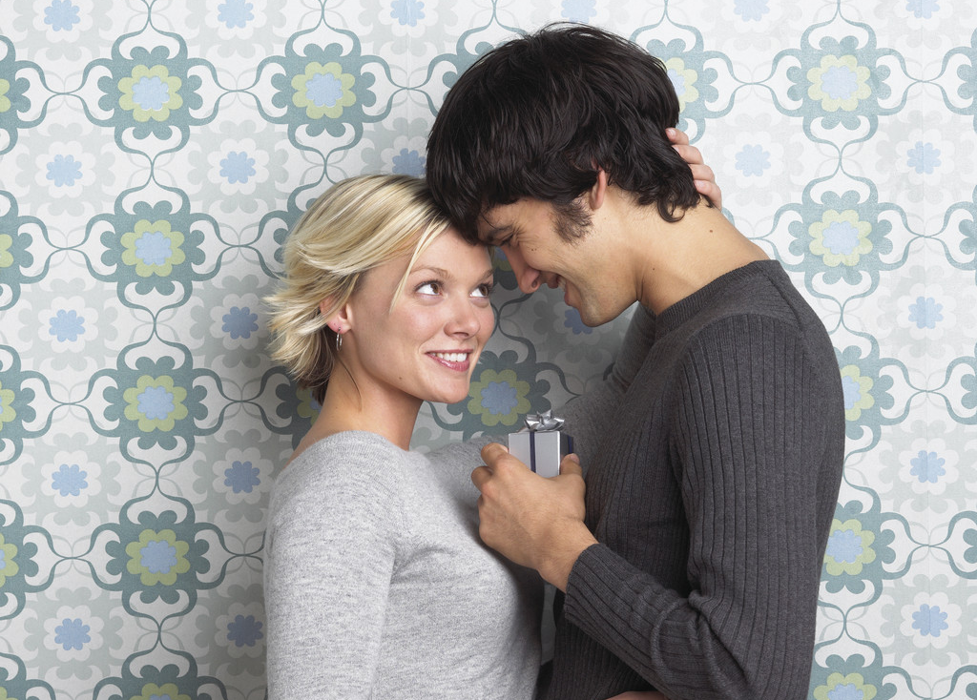
3) Listen to the song, circle the word you hear.
Wonderful Tonight – Eric Clapton (Cover version by Ezra Band)

It’s late in the evening,
she’s wondering what clothes to wear.
She put/puts on her make-up
and brushes her long blonde hair.
Oh when she asks me,
“Do/Does I look all right?”
And I said,
“Yes, you look wonderful tonight.”
We go to a party and everyone turns to see
This beautiful lady
who’s walking around with me.
And then she asks me,
“Does/Do you feel all right?”
And I say, “Yes, I feel wonderful tonight.”
I feel wonderful because I see
the love light in your eyes.
And the wonder of it all
Is that you just don’t/doesn’t realize
how much I love you.
It’s time to go home now
I’ve got an aching head.
So I give her the car keys
and she help/helps me to bed.
Oh and then I tell her,
as I turn out the light,
I say,
“My darling, you were wonderful tonight.”
Say my darling, you were wonderful..
tonight.. tonight.. tonight…
you were wonderful tonight

4) Answer the questions about the song.
- Does the man love the woman? a) Yes, she does. b) Yes, he do. c) Yes, he does.
- Does she put on her make-up? a) Yes, she does. b) Yes, she do. c) No, she doesn't.
- Does she have long brown hair? a) Yes, she does. b) Yes, she do. c) No, she doesn't.
- Do they go to a party? a) Yes, he does. b) Yes, she does. c) Yes, they do.
- Does he feel all right? a) Yes, he does. b) Yes, she does. c) Yes, they do.
- Does she realize how much he loves her? a) Yes, she does. b) No, she does. c) No, she doesn't.
- Does he turn out the light? a) Yes, she does. b) Yes, he does. c) No, he doesn't.
Pokyny:
Materiál seznamuje žáky s použitím pomocných sloves „do“ a „does“ v otázce v přítomném čase prostém a s krátkou odpovědí. Po úvodním seznámení následuje krátké doplňovací cvičení. Druhá strana pracovního listu obsahuje poslechové cvičení – Wonderful Tonight (Eric Clapton/Ezra Band), s nímž souvisí další procvičení otázek v přítomném čase prostém.

Řešení:

1. Fill in „do/does/don't/doesn't“.
- Do you like swimming? – Yes, I do.
- Does he play football? – Yes, he does.
- Do they go to the cinema in the evening? – Yes, they do.
- Do you walk to school every day? – No, I don't.
- Does she play the piano? – No, she doesn't.
- Do Mark and Bob go to the park on Saturdays? – No, they don't.

2. Listening – song dostupný na: http://www.youtube.com/watch?v=tSGAERiYelk
Před samotným poslechem je nutno vyplnit cvičení 1. a 2., které žáky seznámí se slovní zásobou z textu. Pokud je to nutné, projdeme s žáky před poslechem celý text a doplníme další neznámou slovní zásobu.

1) Write the verbs in the 3rd person singular: 2) Match the words
wonderful cítit se
I put on – she puts on feel miláček
I brush – she brushes light báječný
I ask – she asks realize světlo
I turn – she turns aching head uvědomit si
I help – she helps turn out zhasnout
darling bolavá hlava
3) Listen to the song, circle the word you hear.

Wonderful Tonight – Eric Clapton (Cover version by Ezra Band)

It’s late in the evening,
she’s wondering what clothes to wear.
She put/puts on her make-up
and brushes her long blonde hair.
Oh when she asks me,
“Do/Does I look all right?”
And I said,
“Yes, you look wonderful tonight.”
We go to a party and everyone turns to see
This beautiful lady
who’s walking around with me.
And then she asks me,
“Does/Do you feel all right?”
And I say, “Yes, I feel wonderful tonight.”
I feel wonderful because I see
the love light in your eyes.
And the wonder of it all
Is that you just don’t/doesn’t realize
how much I love you.
It’s time to go home now
I’ve got an aching head.
So I give her the car keys
and she help/helps me to bed.
Oh and then I tell her,
as I turn out the light,
I say,
“My darling, you were wonderful tonight.”
Say my darling, you were wonderful..
tonight.. tonight.. tonight…
you were wonderful tonight

4) Answer the questions about the song.
- Does the man love the woman? a) Yes, she does. b) Yes, he do. c) Yes, he does.
- Does she put on her make-up? a) Yes, she does. b) Yes, she do. c) No, she doesn't.
- Does she have long brown hair? a) Yes, she does. b) Yes, she do. c) No, she doesn't.
- Do they go to a party? a) Yes, he does. b) Yes, she does. c) Yes, they do.
- Does he feel all right? a) Yes, he does. b) Yes, she does. c) Yes, they do.
- Does she realize how much he loves her? a) Yes, she does. b) No, she does. c) No, she doesn't.
- Does he turn out the light? a) Yes, she does. b) Yes, he does. c) No, he doesn't.

