Název školy: Základní škola Chomutov, Písečná 5144
Název materiálu: VY_22_INOVACE_23_There_is_There_are_ig1
Číslo projektu: CZ 1.07/1.4.00/21.3355
Autor: Mgr. Iveta Gobbiová
Datum tvorby: 14.01.2012
Cílový ročník: 1. - 3. třída
Vzdělávací oblast/obor/okruh: Anglický jazyk
Klíčové slovo: there is, there are
Anotace: Pracovní listy jsou určeny pro žáky 1.-3.tříd.Slouží k aktivnímu používání spojení there is/there are, k tvorbě vět.
Make a sentence :
are
two
dogs.
There

is
a
snake.
black
small
There

four
cats.
are
There

hippo.….
There
a

is
small

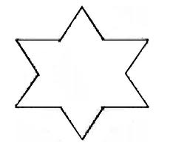
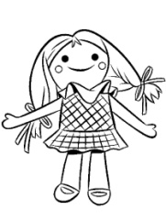
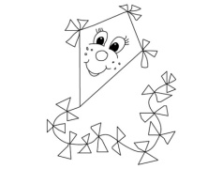
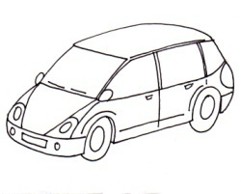
Write the answers :
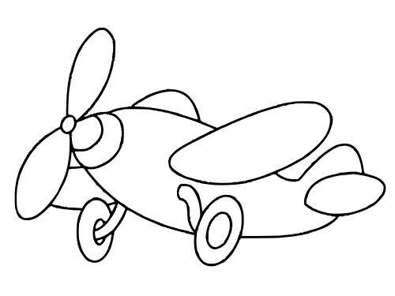
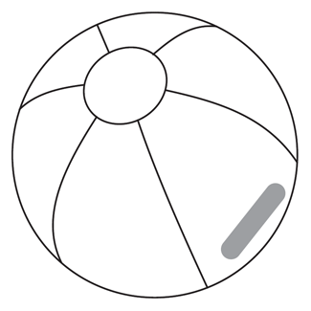

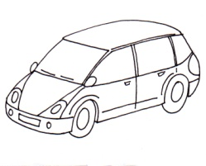
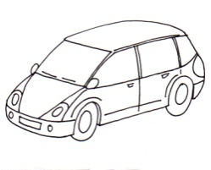

- How many stars are there?
…………………………………………………………………
- How many boys are there?
…………………………………………………………………
- How many cars are there?
…………………………………………………………………
- How many kites are there?
…………………………………………………………………
- How many balls are there?
…………………………………………………………………
- How many aeroplanes are there?
…………………………………………………………………
- How many dolls are there?
…………………………………………………………………
Článek :I have got a big box.
There are two old books in my box.
There is a big elephant in my box.
There are three red cars in my box.
There are four long green snakes and one parrot in my box.
There is a blue car in my box.

Now write : Yes, there is/are.
No, there isn´t/aren´t.

- Is there an old book in my box? …………………………………………
- Is there a red car in my box? …………………………………………………
- Are there two old books? ………………………………………………………….
- Are there three long green snakes in my box? ……………………………
- Are there five parrots in my box? ………………………………………………
- Is there a small elephant in my box? …………………………………………
- Is there a black car in my box? …………………………………………………
- Is there a blue car in my box? ……………………………………………………..

Read and match, write the letter :
A 
B 

C 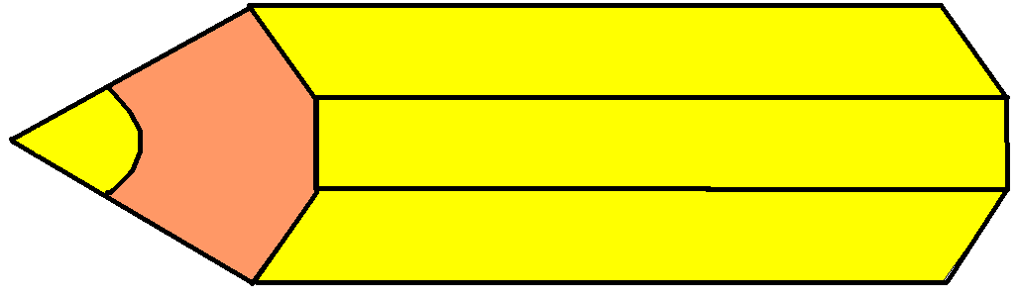

D
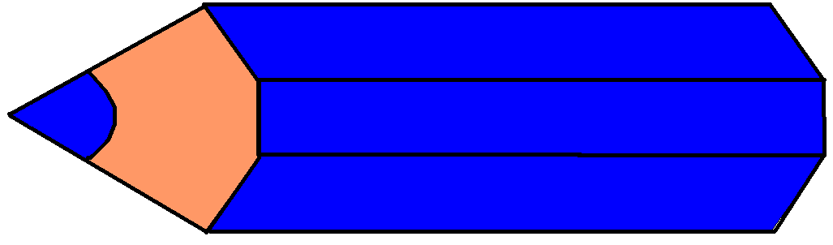
E

- There´re two red pencils.
- There´s a blue pencil.
- There´s a red pencil.
- There´re four green pencils.
- There´re three yellow pencils.

Write is ( ´s ) or are (´re) :

- There ……………….. a happy monkey.
- There ……………….. two big elephants.
- There ……………….. five red cars.
- There ……………….. a hat on my head.
- There ……………….. a big hippo on my picture.
- There ……………….. three parrots on the tree.
- There ……………….. a small snake.
- There ……………….. six dogs on the garden.
- There ……………….. eight birds.
- There ……………….. a doll.

14.1.2012
Zdroje :
hvězda -http://www.domaci-napady.cz/wp-content/uploads/2007/12/sablona-hvezda-svicen.thumbnail.jpg
kluk - http://www.folievarecha.cz/images/11690_11693_dite-v-aute.jpg
auto - http://www.predskolaci.cz/wp-content/uploads/2009/05/auto-osobni-150x120.jpg
letadlo - http://omalovánky.eu/omalov%C3%A1nky/small_1194.jpg
míč - http://www.reklama-centrum.cz/predmety/potisky/39-8094xx.gif
papírový drak - http://www.omalovankykvytisknuti.info/wp-content/gallery/Papirovy%20drak/thumbs/thumbs_podzimni-drak-1.jpg
zelená pastelka - http://www.clipartpal.com/_thumbs/pd/education/stubby_pencil_w_shadow_green.png
červená pastelka - http://www.clker.com/cliparts/9/9/c/b/1215441750781428792klsgfx_Pencils_5.svg.med.png
modrá tužka - http://www.veskole.cz/download/3/2/8/modr%C3%A1%20tu%C5%BEka.bmp
žlutá tužka - http://www.veskole.cz/download/3/5/3/%C5%BElut%C3%A1%20tu%C5%BEka.bmp
panenka - http://www.i-creative.cz/wp-content/uploads/2008/11/panenka.jpg

