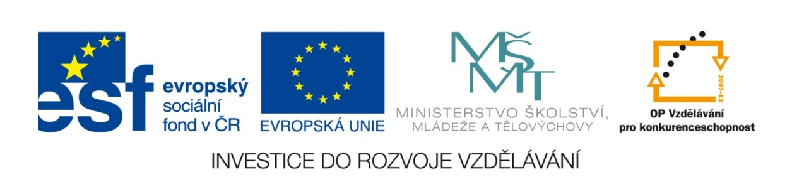

Autor : Vladimír Mizera

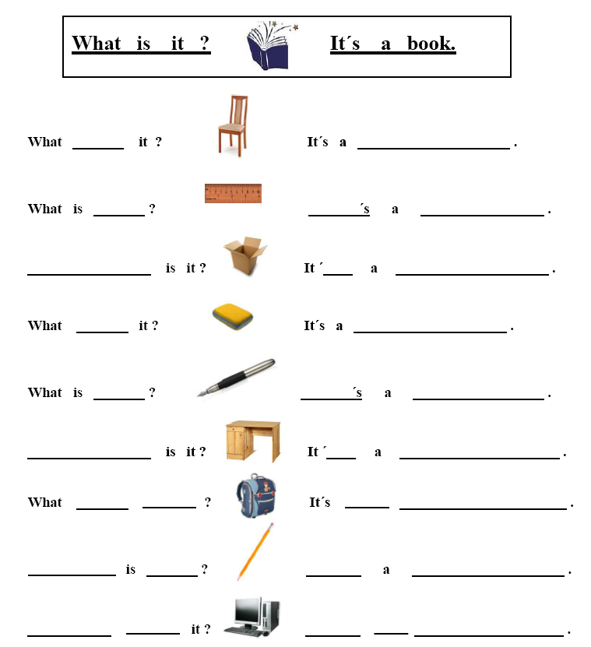

http://www.nabytekdointerieru.cz/_data/s_441/shop/big_66321_img_1259008810.jpg
http://becauseican.co.za/wp-content/uploads/2008/04/ruler_0_10.jpg
http://www.papirove-krabice.cz/wp-content/uploads/2009/07/cardboardbox.jpg
http://www.faqs.org/photo-dict/photofiles/list/1558/2787eraser.jpg
http://www.modico.cz/wp-content/gallery/propisky/thumbs/thumbs_s12_02.jpg
http://www.dk-obchod.cz/media/upload//produkt/VIMAS/VIMAS-505-Psaci-stul-masiv-borovice-SY-102-3-.jpg
http://www.bajecnyobchod.cz/index.php?main_page=product_info&products_id=777
http://www.faqs.org/photo-dict/phrase/459/pencil.html
http://shop.boztek.com.au/index.php?main_page=popup_image&pID=548

