Vacuum cleaner
A vacuum cleaner is a device that uses an air pump to create a partial vacuum to suck up dust and dirt, usually from floors, and optionally from other surfaces as well. The dirt is collected by either a dustbag or a cyclone for later disposal. Vacuum cleaners, which are used in homes as well as in industry, exist in a variety of sizes and models — small battery-operated hand-held devices, domestic central vacuum cleaners, huge stationary industrial appliances that can handle several hundred litres of dust before being emptied, and self-propelled vacuum trucks for recovery of large spills or removal of contaminated soil.

Robotic
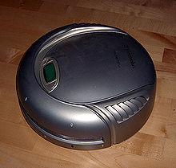

Describe your home vacuum cleaner – size, colour.
How long have you had the appliance?
How often does your family use it and do you help with tidying too?
Don´t you mind helping or would you like to change the rules ?

_____________________________________________________________________________________________________________________________________________________________________________________________________________________________________________________________________________________________________________________________________________________________________________________________________________________________________________________________________________________

