This painting is called …………………………………….
…author…………was born in ….………..…. in ……year……….
He died in …… year ………………
……the text about the painting……………………………………………………………………………
…………………………………………………………………………………………………..……

This painting is called …………………………………….
…author…………was born in ….………..…. in ……year……….
He died in …… year ………………
……the text about the painting……………………………………………………………………………
…………………………………………………………………………………………………..……

This painting is called …………………………………….
…author…………was born in ….………..…. in ……year……….
He died in …… year ………………
……the text about the painting……………………………………………………………………………
…………………………………………………………………………………………………..……

This painting is called …………………………………….
…author…………was born in ….………..…. in ……year……….
He died in …… year ………………
……the text about the painting……………………………………………………………………………
…………………………………………………………………………………………………..……
The yellow colour of the flowers
symbolizes the sun.

This painting takes you back
to beginning of Christianity.
Family is the basic stone.

The author had dark eyes and dark
hair. His beard covered his chin.
Maybe, his favourite colour was black.

The sun is shining through the crowns
of trees. It´s a beautiful day.
People are wearing hats.
What are the adults talking about?

Look at their clothes , hats and boots
- the painter showed each detail.
Doesn´t matter there is the dark night.

Two lovers are hiding in the bunch
of flowers. The Moon and the river
below can´t see them.

This painting is blured .
Would you like see the building
better? - Close your eyes a little.

Sad coutryside and the dark sky above
– where are the people going?

Many people came to the
celebration. They are
enjoying it.

The young lady is watching you with a mild
smile. You can see an Italian countryside
behind her.

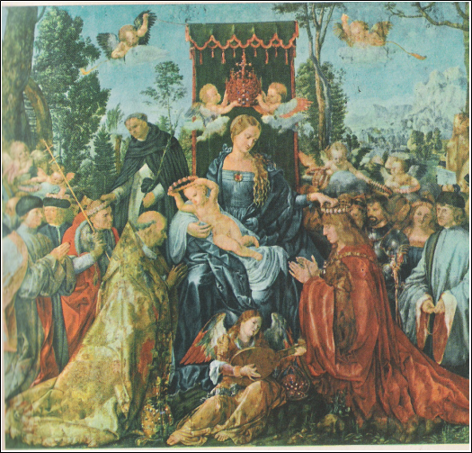
Rosenkranzfest

Albrecht Dürer
Germany
* fourteen seventy-one
+ fifteen twenty-eight

Bonjour, Monsieur Gauguin

Paul Gauguin
France
* eighteen forty-eight
+ nineteen oh-three
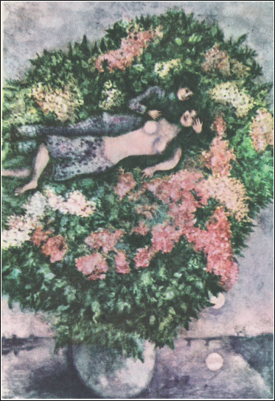
Bouquet of Flowers

Marc Chagall
Russia
* eighteen eighty-seven
+ nineteen eighty-four

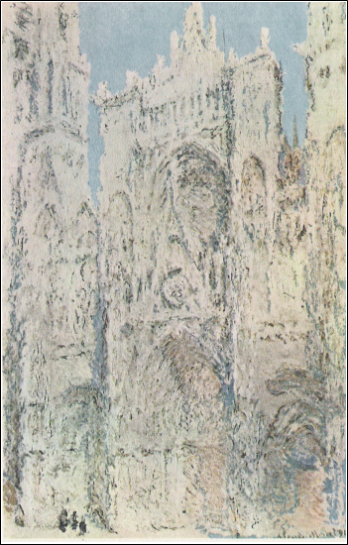
The Cathedral in Rouen

Claude Monet
France
* eighteen forty
+ nineteen twenty-six

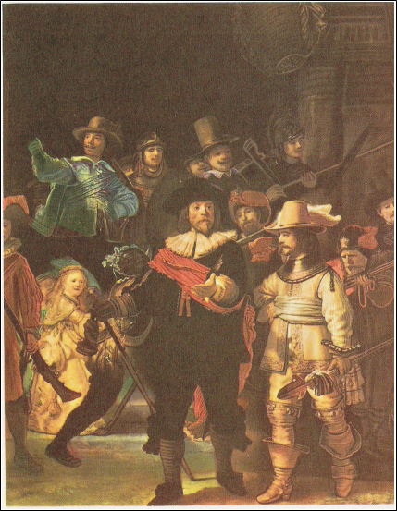
The Night Guard

Rembrant van Rijn
Holand
* sixteen oh-six
+ sixteen sixty-nine
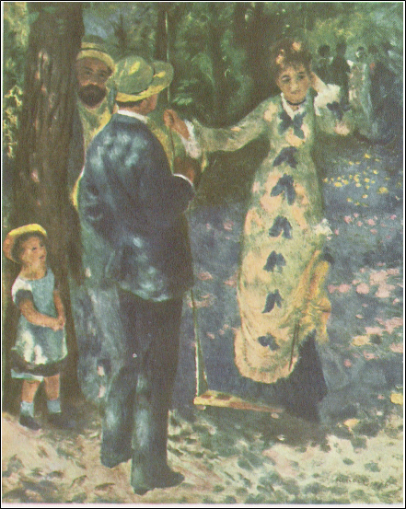
The Swing

Pierre Auguste Renoir
France
* eighteen forty-one
+ nineteen nineteen
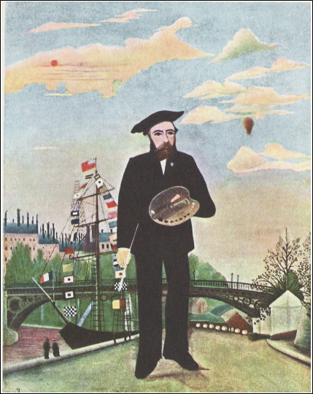
Self Portrait

Henri Rousseau
France
* eighteen forty-four
+ nineteen ten

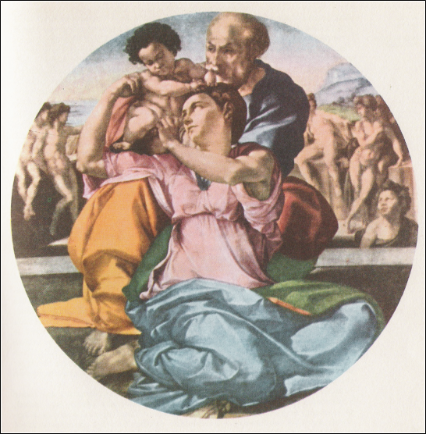
The Holy Family

Michelangelo Buonarroti
Italy
* fourteen seventy-five
+ fifteen sixty-four
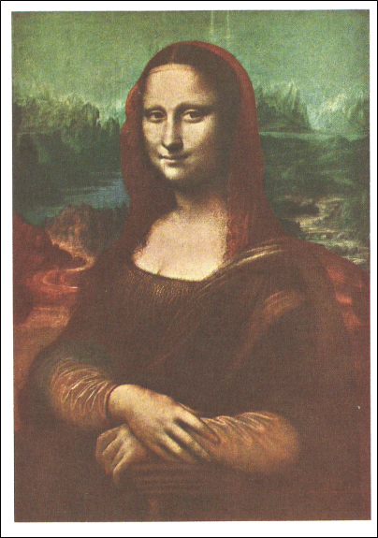
Mona Lisa

Leonardo da Vinci
Italy
* fourteen fifty-two
+ fifteen nineteen
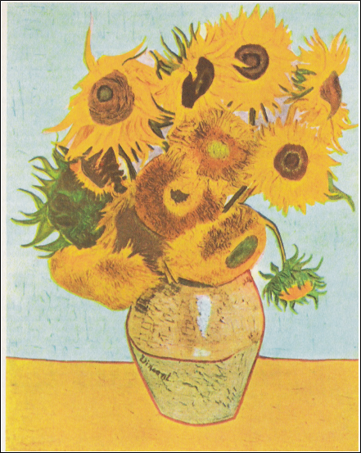
The Sunflowers

Vincent van Gogh
Holand
* eighteen fifty-three
+ eighteen ninety

