VY_32_INOVACE_B10_True stories2

Ročník: | 8.
Vzdělávací oblast: | Jazyk a jazyková komunikace
Vzdělávací obor: | Anglický jazyk
Tematický okruh: | Poslech
Téma: | Rozvoj poslechových dovedností
Jméno autora: | Mgr. Miroslava Kuchrýková
Vytvořeno dne: | 1.6.2011
Metodický popis,  (anotace): | Materiál slouží k rozvíjení poslechových dovedností. Žáci poslouchají text a snaží se doplnit chybějící části textu. (text čte učitel)

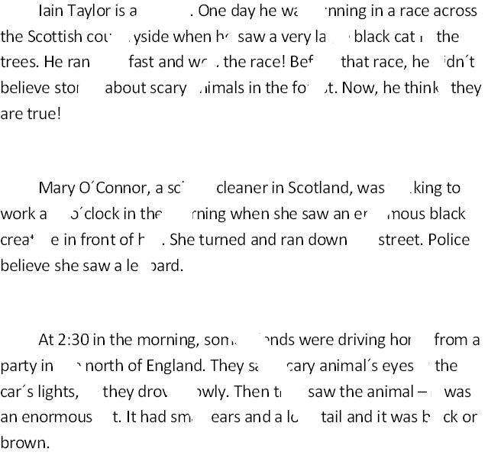

Solution:

Iain Taylor is a runner. One day he was running in a race across the Scottish countryside when he saw a very large black cat in the trees. He ran very fast and won the race! Before that race, he didn´t believe stories about scary animals in the forest. Now, he thinks they are true!

Mary O´Connor, a school cleaner in Scotland, was walking to work at 6 o´clock in the morning when she saw an enormous black creature in front of her. She turned and ran down the street. Police believe she saw a leopard.

At 2:30 in the morning, some friends were driving home from a party in the north of England. They saw scary animal´s eyes in the car´s lights, so they drove slowly. Then they saw the animal – it was an enormous cat. It had small ears and a long tail and it was black or brown.

Zdroj: HARRIS, Michael; MOWER, David; SIKORZYNSKA, Anna. Challenges 2(workbook). England: Pearson Longman, 2006, ISBN 978-0-582-84676-0.

