Autor: Mgr. Magda Knapová

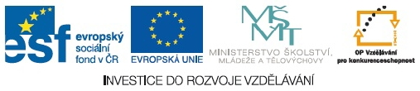

WORDSEARCH - SPORTS

V T S O R F A S N G U L Q J V
K O D C V O W D Y T C L H B P
L U L X I I W M M Y B A A J N
J L H L M T N I C Z T B N C N
J M A M E A E L N M P T D P Q
T E I B S Y I L S G G E B U Y
S N M T T N B I H Y J K A G R
G D I S G O N A M T L S L B W
U C W V G N O F L H A A L A V
S T O T E X D F T L M B E S M
N Z L T Y E K C O H E C I E Q
B A D M I N T O N I U R Z B I
S K A T I N G D Y B G U R A W
A U Z R V T F S K I I N G L Z
H Q F C R N S O S I Q B R L M

ATHLETICS
BADMINTON
BASEBALL
BASKETBALL
CYCLING
FOOTBALL
GYMNASTICS
HANDBALL
ICEHOCKEY
JUDO
ROWING
RUGBY
SKATING
SKIING
SWIMMING
TENNIS
VOLLEYBALL

