

Autor: Mgr. Magda Knapová



WHAT´S THE RESULT? COUNT
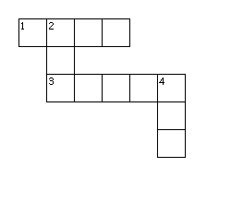
Across
1. 20:5
3. 16:2
Down
2. 12:12
4. 10:1

How many…?

……………………………………………..cars

…………………………………………….balls
……………………………………………pumpkins

