

Autor: Mgr. Magda Knapová



MONTHS
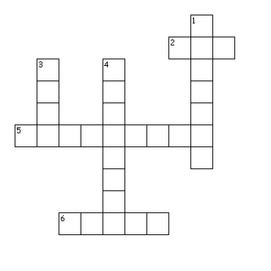
Across
2. fifth month of the year
5. twelfth month of the year
6. third month of the year
Down
1. first month of the year
3. sixth month of the year
4. eleventh month of the year

