

Autor: Mgr. Magda Knapová



DAYS OF THE WEEK

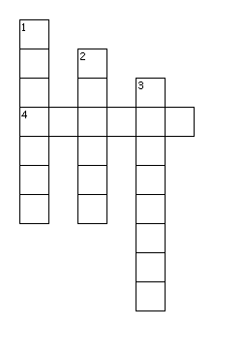
Across
4. TOMORROW WILL BE MONDAY.WHAT IS TODAY?
Down
1. YESTERDAY WAS MONDAY.WHAT IS TODAY?
2. TODAY IS TUESDAY.WHAT WAS YESTERDAY?
3. YESTERDAY WAS FRIDAY.WHAT IS TODAY?

