VY_22_INOVACE_AJK.14

- Autor: Martina Majtánová
- Datum vytvoření: únor 2012
- Ročník: I.stupeň (3.-4.ročník)
- Vzdělávací oblast: Jazyk a jazyková komunikace
- Vzdělávací obor: Anglický jazyk
- Tematický okruh: Rozvoj komunikačních dovedností
- Téma: Části lidského těla



1. What´s this in the human body? (jumbled words - přesmyčky)
GLE - _______________ EHAD - ________________
DYBO - _______________ HDAN - ________________
MAR - _______________ OOTF - _________________
GRINFE - ______________

2. Look at the monster and complete the sentences. (doplň věty)
hands
head
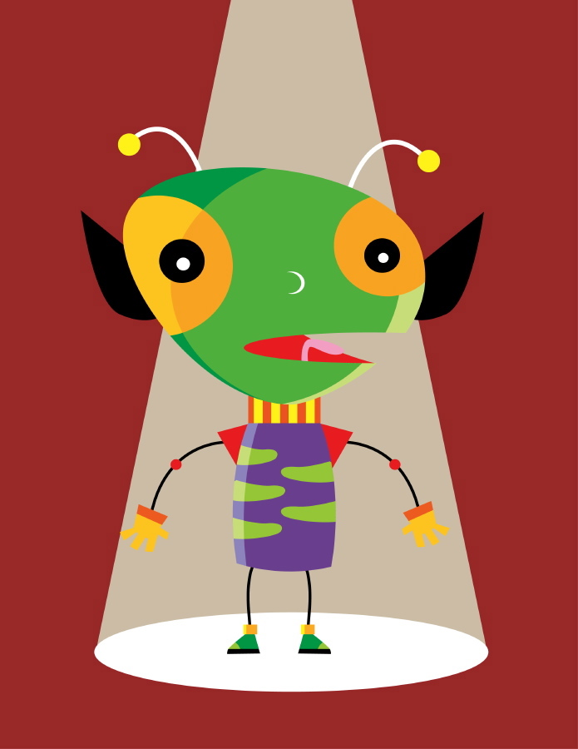
This monster is a girl. Her _______ is Peggy. She has got a very big green ________ and two big eyes. She has got two big black ________, too. She has got a little body. She has got long _________ and short legs. She has got big ________ and _________ feet.
name
arms
ears
little

3. Look at the picture and write about the monster. (popiš příšeru)
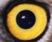
This monster is a boy. His name is Joe.
He has got………………………………………

Anotace
- Pracovní list navazuje na prezentaci DUMAJK.11
- Cíl: žák si upevní psanou podobu částí těla, doplní text o příšeře a sám popíše jinou příšeru

Reference
- [cit. 2012-02-21]. Obrázky dostupné pod licencí Microsoft Office2010 na Office.com

Řešení
1. LEG , BODY, ARM, FINGER, HEAD, HAND, FOOT
2. This monster is a girl. Her __NAME__ is Peggy. She has got a very big green __HEAD__ and two big eyes. She has got two big black __EARS__, too. She has got a little body. She has got long __ARMS__ and short legs. She has got big __HANDS__ and _LITTLE__ feet.
3. This monster is a boy. His name is Joe. He has got two heads. He has go tone big yellow eye. He has got a big body. He has got two long arms ang short legs. He has got very long fingers.

