M | K | L | E | L | E | P | H | A | N | T | A | V | G | T
E | M | V | W | F | Q | R | H | I | N | O | T | J | I | D
K | O | C | T | O | P | U | S | R | P | P | N | C | G | H
A | L | R | A | M | W | K | B | U | Z | P | Y | B | L | T
N | M | O | N | K | E | Y | E | P | C | R | O | U | F | S
G | Z | C | Y | X | E | L | A | H | W | T | S | U | W | N
A | D | O | W | L | A | L | R | O | P | N | T | F | H | A
R | W | D | N | B | N | Q | Y | Z | U | F | R | O | G | K
O | L | I | O | N | R | I | U | M | M | V | I | C | K | E
O | D | L | E | H | V | N | U | C | X | Z | C | U | A | V
W | R | E | Q | L | D | J | I | G | T | R | H | G | A | P
H | B | F | I | U | G | F | B | C | N | N | L | E | L | G
P | A | R | R | O | T | B | N | M | G | E | H | T | I | F
O | T | Y | X | R | T | H | F | D | O | L | P | H | I | N
C | A | M | E | L | A | F | G | I | R | A | F | F | E | W
1. Find wild animals (21)

1/A. What animal is it?
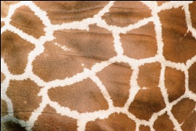 It´s a ______________ 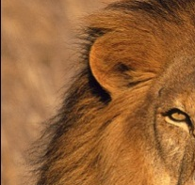 It´s a ____________
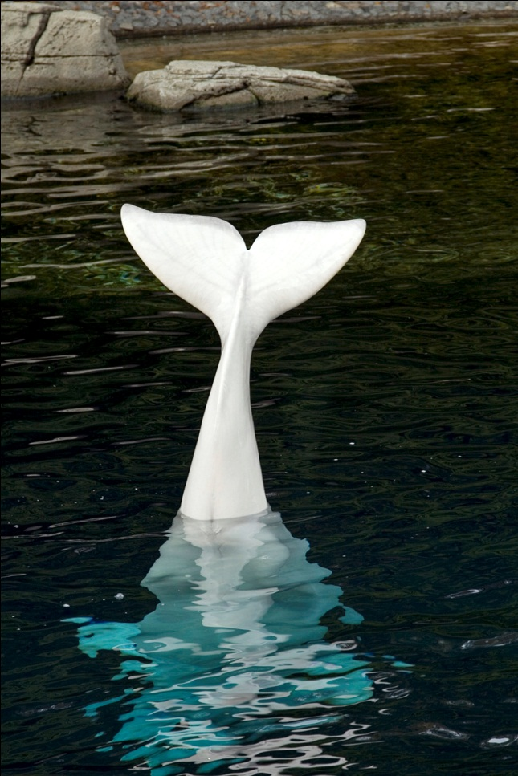 ___________________ ________________
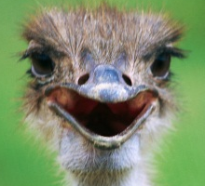 ___________________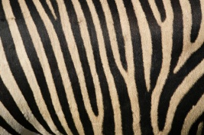 _______________
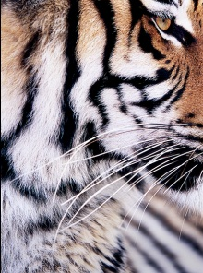 ___________________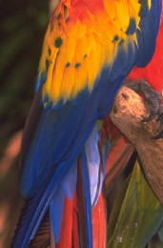 _________________
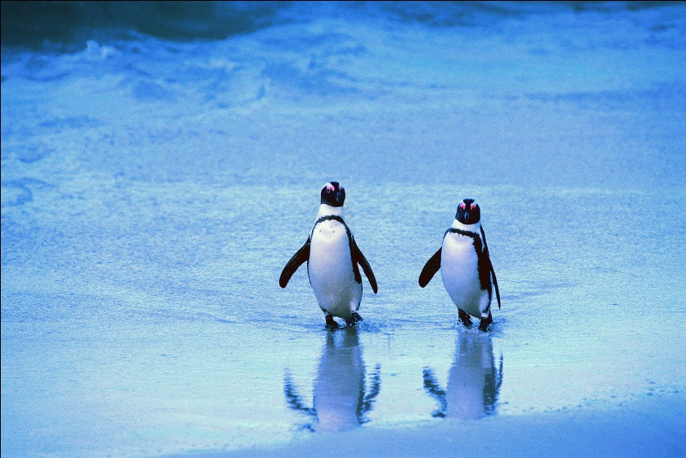 __________________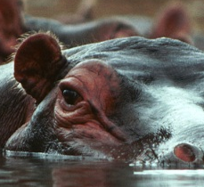 _________________
____________________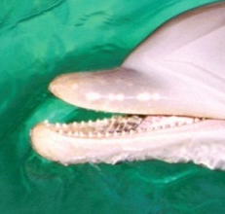 __________________
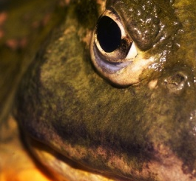 ________________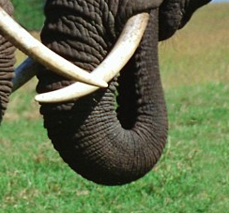 _________________

1/B. What animal is it?
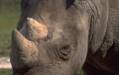 It´s a______________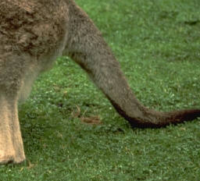 It´s a_____________
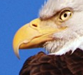 __________________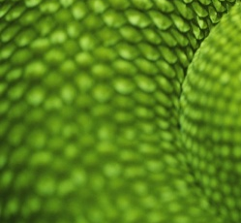 _________________
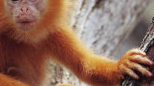 _________________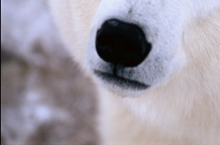 ________________
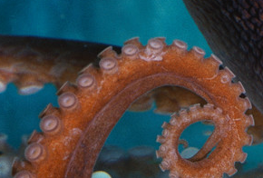 _______________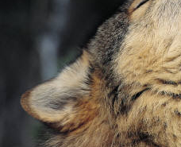 ________________
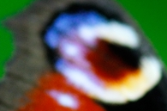 ________________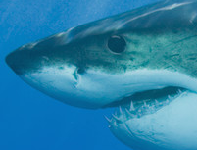 _________________
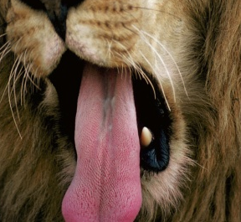 ________________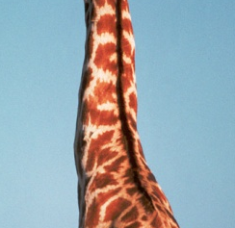 ________________
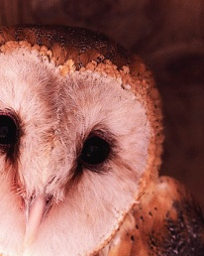 ___________________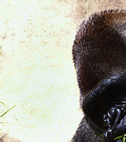 ________________
2. What are your favourite animals? Draw!
My favourite animals are …

VY_22_INOVACE_AJK.23

- Autor: Martina Majtánová
- Datum vytvoření: únor 2012
- Ročník: I.stupeň (4.-5.ročník)
- Vzdělávací oblast: Jazyk a jazyková komunikace
- Vzdělávací obor: Anglický jazyk
- Tematický okruh: Rozvoj komunikačních dovedností
- Téma: Divoká zvířata



Anotace
- PL navazuje na prezentaci DUM AJK.21
- Cíl: žák si upevní psanou podobu slov v osmisměrce, vyjmenuje divoká zvířata, nakreslí a mluví o svých oblíbených zvířatech
Reference
- [cit. 2012-02-23]. Obrázky dostupné pod licencí Microsoft Office 2010 na Office.com
Řešení
1/A. giraffe, lion, whale, camel, ostrich, zebra, tyger, parrot, penguin, hippo, bat, dolphin, frog, elephant
1/B rhino, kangaroo, eagle, snake, monkey, polar bear, octopus, wolf, butterfly, shark, lion, giraffe, owl, gorilla
 |  |  | E | L | E | P | H | A | N | T
 |  |  |  |  |  | R | H | I | N | O
K | O | C | T | O | P | U | S |  | P
A |  | R |  |  |  |  | B |  |  | P
N | M | O | N | K | E | Y | E |  |  |  | O |  |  | S
G |  | C |  |  | E | L | A | H | W |  | S |  |  | N
A |  | O | W | L |  |  | R |  |  |  | T |  |  | A
R |  | D |  |  | N |  |  |  |  | F | R | O | G | K
O | L | I | O | N |  | I |  |  |  |  | I |  |  | E
O |  | L |  |  |  |  | U |  |  |  | C |  | A
 |  | E |  |  |  |  |  | G |  |  | H | G
 | B |  |  |  |  |  |  |  | N |  | L
P | A | R | R | O | T |  |  |  |  | E
 | T |  |  |  |  |  |  | D | O | L | P | H | I | N
C | A | M | E | L |  |  | G | I | R | A | F | F | E
ELEPHANT, RHINO, OCTOPUS, MONKEY, OWL, FROG, LION, PARROT, DOLPHIN, CAMEL, GIRRAFFE
KANGAROO, CROCODILE, BAT, BEAR, OSTRICH, SNAKE
HIPPO PENGUIN EAGLE WHALE

