NAME:_________________________________________

1. What´s the time?

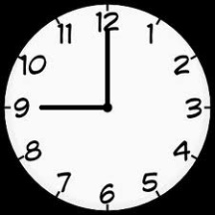

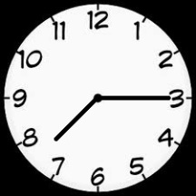

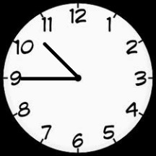

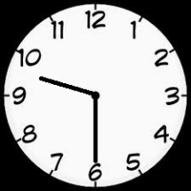

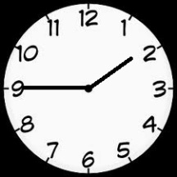

2. It´s……………
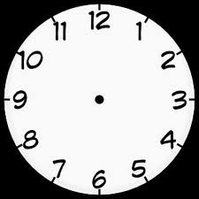
six o´clock quarter past six half past nine quarter past eleven quarter to five

3. Match: English word – anagram – Czech word

GEOGRAPHY SCIENCE MATHS MUSIC

TAHSM HPARGEOGY INECSCE CMUIS

HUDEBNÍ VÝCHOVA MATEMATIKA PŘÍRODOVĚDA VLASTIVĚDA

4. Match the subjects with activities

ART PE ENGLISH CZECH CRAFT

learn new words cut paper and make things write dictation

draw and colour pictures run and jump

Zdroj obrázků:
hodiny: http://t3.gstatic.com/images?q=tbn:ANd9GcTpaSTykBRauNv-T7YZESZIELTkJG4lfblXVOjINfzum5XEYEC9

