ANIMALS

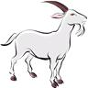
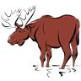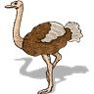

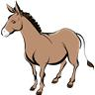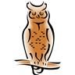

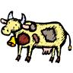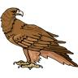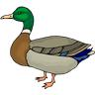

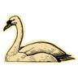

- WORK WITH A PARTNER. WRITE THE NAMES OF THE ANIMALS. USE A DICTIONARY IF YOU NEED.

- WRITE THE WORDS FROM EXERCISE 1 IN THE CORRECT COLUMN. SOMETIMES MORE EXAMPLES ARE POSSIBLE.

WILD ANIMALS | FARM ANIMALS | THEY LIVE IN WATER | THEY CAN FLY

- CIRCLE THE RIGHT ANSWER.

WHICH ONE…

- IS A BIRD? A FOX / A HAMSTER / A PENGUIN
- ISN´T A MAMMAL? A RAT / A SNAKE / A MOUSE
- EATS INSECTS? A MOLE / A WOLF / A COW
- IS A WILD ANIMAL? A HEN / A PIG / A ZEBRA
- CAN FLY? A BEAR / A SPARROW / A WHALE
- IS A MAMMAL? A FROG / A SEAL / A SHARK
- IS DANGEROUS FOR PEOPLE? A LION / A SHEEP / AN ANT
- DOESN´T LIVE IN A FOREST? A DEER / AN OWL / A CHICKEN
- LIVES IN WATER? A BUTTERFLY / A RABBIT / A HIPPO
- LAYS THEIR EGGS IN WATER? A KANGAROO / A FROG / A MONKEY

- WORK WITH YOUR PARTNER AND ANSWER THE QUESTIONS.

- WHAT ARE YOUR FAVOURITE ANIMALS? WHY?
- WHAT ANIMALS DON´T YOU LIKE? WHY?
- WHAT PETS DO YOU HAVE/ WOULD YOU LIKE TO HAVE AT HOME?

ZDROJE: Vlastní zdroje autora
OBRÁZKY: www.microsoft.office.com

