Název školy: ZŠ Varnsdorf, Edisonova 2821, okres Děčín, příspěvková organizace
Jazyk a jazyková komunikace, Anglický jazyk, Velká Británie - kvíz
Autor: Michaela Galbavá, DiS.
Název materiálu: VY_22_INOVACE_34/I.SADA

Anotace:
Výukový materiál je určen pro žáky II.stupně ZŠ, slouží k opakování základních informací o Velké Británii formou kvízu.
Období: září – prosinec 2011

1. What Do You Know About Great Britain?
Great Britain is made up of England, (1)...................., (2) ……………… and (3)..................... The full, official name of the country is (3 )..................................... ......................................... The national flag of the UK is the (4)................... Jack. The capital of the UK, London, lies on the River (5)................. . The highest mountain in the UK is (6)......................... in the Highlands of Scotland, at 1,343 m. The longest river is the (7)...................., 354 km long. The population of the UK is about (8)................ million The British Parliament consists of the House of (9).................... and the House of (10).................... The (11)...................of London is one of the most important financial centres in the world. (12)....................... Palace is the official residence of the Queen (13) ........................
2. Write the names of these famous symbols of London.
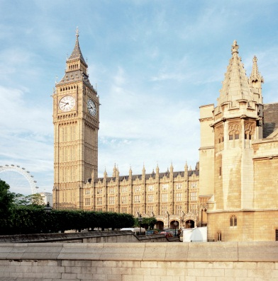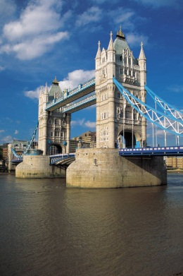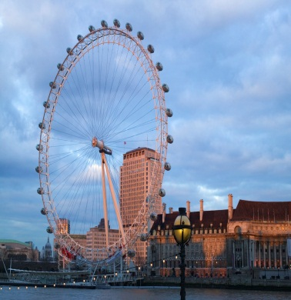
______________________ ________________ _____________________

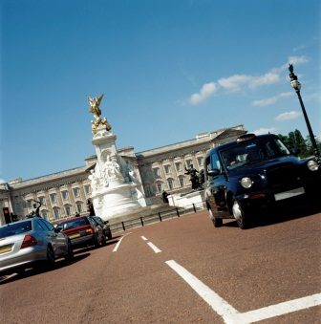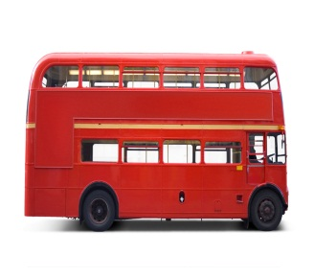
___________________ ________________ ________________

3.Choose the correct answers.
- What's the capital of the Republic of Ireland?
- Cardiff b) Dublin c) London d) Belfast
- What is the capital of Scotland?
- Glasgow b) Dover c) Aberdeen d) Edinburgh
- What is the highest mountain in Britain?
- Mount McKinley b) Snowdon c) Ben Nevis d) Swan Lake
- Which island lies between England and Ireland?
- The Isle of Man b) Elis Island c) Shetland Islands d) The Isle of Skye
- What is the flag of the UK called?
a) Tricolore b) United Kingdom c) Union Jack d) Stars and Stripes
Použité zdroje:
- Veškeré obrázky prezentace použity z galerie Office.Microsoft.com, citováno 20.11.2011

