Od dotace EU k proměně vyučovací hodiny
registrační číslo projektu: CZ.1.07/1.4.00/21.0196

Příjemce:
Základní škola, Základní umělecká škola a Mateřská škola
Lipnice nad Sázavou č. 213,
582 32 Lipnice nad Sázavou
Téma hodiny: Henry VIII. Reading with comprehension,
questions.
Doporučeno pro: 8. a 9. ročník
Předmět: Anglický jazyk
Autor: Pavlína Dolejšová
Kód: Cizí jazyky -Inovace – 5Aj8

Materiál je určen pro bezplatné používání pro potřeby výuky a vzdělávání na všech typech škol
a školských zařízení.
Jakékoliv další využití podléhá autorskému zákonu.

Tento výukový materiál vznikl v rámci Operačního programu Vzdělávání pro konkurenceschopnost.

Henry VIII

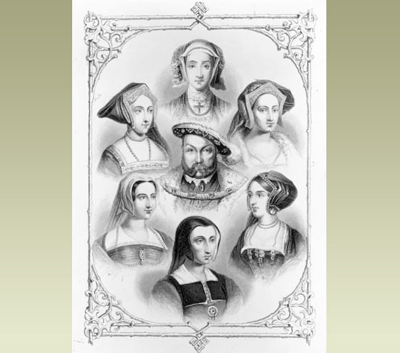

Obr. 1

Read the information about Henry VIII and complete the questions below.

The king with six wives
Henry was the King of England who had six wives. But Henry did lots of other things besides marrying six times. He wanted to make England strong. Most of all, he wanted a son to be king after him.
When did he live?
Henry was born in 1491. In English history, the time when he and his family lived is known as the Tudor age. Tudor was Henry's family name.
Henry lived at a time of changes. People had new ideas in art, science and religion. They sailed off to explore new lands. Henry died in 1547. Three of his children ruled England after him.
Why do people remember Henry?
Paintings of Henry VIII show a big, fierce-looking man in fine clothes. He looks scary, and many people were scared of him. If the King did not get his way, he got cross. People who made him cross risked having their heads chopped off!
As a young man, Henry was handsome and clever. He was good at sport, music and dancing. He wanted to be a soldier and a famous king.

Exercise 1:
Complete the questions. Use the text to help you.
- How many …………………………………………………………..? - Six.
- How …………… the time when he and his family lived ……………….? - The Tudor age.
- What …………………………………………………….… name? - Tudor.
- …………………………………………. born? - In 1491.
- …………………………………… of his children ………………………………………………..? - Three.
- ……………………………… look like in paintings? - He looks scary.
- ……………………………………………. as a young man? – He was handsome and clever.
- ………………………………………………………………….? A soldier and a famous king.

Henry's six wives

Henry's divorce
Henry's first wife was Catherine of Aragon. She was a Spanish princess. In 1511, Catherine had a son, but the baby died.
Catherine and Henry had a daughter, Mary. But no son. So in 1533, Henry decided to divorce Catherine, so he could marry someone else.
Henry and the Church
Divorce was against the rules of the Roman Catholic Church. Most people in England were Christians, and members of this Church. Henry was too. But he broke the rules. He got his divorce. He made himself head of the Church in England.
Wives 2 and 3
Henry's second wife was Anne Boleyn. She had a daughter, Elizabeth. Henry turned against Anne, and she was beheaded in 1536.
Next Henry married Jane Seymour. In 1537, she had a son, Edward, but she died two weeks later. Henry was very sad.
Wives 4-5-6
Henry's fourth wife (1540) was Anne of Cleves, from Belgium. Henry had never seen her until she came to England for the wedding. He divorced her after six months.
He soon married again. His fifth wife was Catherine Howard. She was only 19. She was beheaded in 1542.
Henry's sixth wife was Catherine Parr, a widow. She looked after his children.

Exercise 2:
Answer the questions. Use the text.
- Who was Henry’s second wife? ………………………………………………………………………………….
- Who did Henry divorce? ……………………………………………………………………………………………..
- How many of Henry’s wives had their heads cut off? ………………………………………………….
- Where did Catherine of Aragon come from? ……………………………………………………………..
- What were the names of Henry’s famous daughters? ………………………………………………..
- How old was Catherine Howard when she married Henry VIII? …………………………………
- What was the name of Henry’s wife who came from Belgium? ………………………………….
- Who was the last wife of Henry VIII? …………………………………………………………………………..

Answers:
EX 1:
- How many wives had Henry VIII got?
- How is the time when he and his family lived known?
- What was Henry’s family name?
- When he was born?
- How many of his children ruled England after him?
- What does he look like in paintings?
- What did he look like as a young man?
- What did he want to be?
EX 2:
- Anne Boleyn.
- Catherine of Aragon.
- Two.
- Spain.
- Mary and Elizabeth.
- Nineteen.
- Anne of Cleves.
- Catherine Parr.

Autorská práva, odkazy, soupis citací, zdroje jsou chráněné dle zákona 121/2000 sb.

Zdroje:
http://www.helpforenglish.cz/gramatika/ruzne/slovosled/otazky/c2006110501--c-questions--brad-pitt.html

http://www.bbc.co.uk/schools/primaryhistory/famouspeople/henry_viii/

Obr. 1

http://www.bbc.co.uk/schools/primaryhistory/famouspeople/henry_viii/

Jméno autora práce: | Bc. et Bc. Pavlína Dolejšová
Datum vytvoření: | Leden 2012
Ročník: | 8. a 9.
Vzdělávací oblast:  Vzdělávací obor:  Tematický okruh:  Téma: | Jazyk a jazyková komunikace, cizí jazyk  Anglický jazyk  Reálie - historie  Henry VIII
Metodický list (anotace): | Čtení 2 textů o Jindřichu VIII a jeho manželkách, porozumění textu, tvoření o odpovídání na otázky vyplývající z textů.

