Od dotace EU k proměně vyučovací hodiny
registrační číslo projektu: CZ.1.07/1.4.00/21.0196

Příjemce:
Základní škola, Základní umělecká škola a Mateřská škola
Lipnice nad Sázavou č. 213,
582 32 Lipnice nad Sázavou
Téma hodiny: Queen Victoria. Reading with
comprehension, questions.
Doporučeno pro: 8. a 9. ročník
Předmět: Anglický jazyk
Autor: Pavlína Dolejšová
Kód: Cizí jazyky -Inovace – 6Aj8

Materiál je určen pro bezplatné používání pro potřeby výuky a vzdělávání na všech typech škol
a školských zařízení.
Jakékoliv další využití podléhá autorskému zákonu.

Tento výukový materiál vznikl v rámci Operačního programu Vzdělávání pro konkurenceschopnost.

Queen Victoria

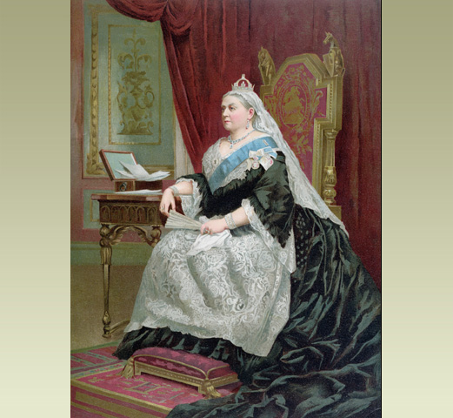

Obr. 1

Queen for an age
People all over the world know the name of Queen Victoria. She is probably the most famous queen in history. She was Queen of a vast empire, as well as of Britain. A long period of history is named after her - the Victorian Age.
What does 'Victorian' mean?
It means 'to do with Victoria'. It's an adjective used to describe people and things from her time. Victoria was Queen for over 60 years. Many things happened during her life. We talk about 'Victorian' buildings or 'Victorian' furniture. This doesn't mean that Queen Victoria made them herself! It usually means something dates from the 1800s.
When did she live?
Victoria was born in 1819. She became Queen in 1837 when she was 18. Her reign lasted for more than 60 years. Queen Victoria was born early in the 19th century. She lived to see the start of the 20th century, dying in January 1901.

The Royal Family
A growing family
Victoria had four sons and five daughters. Her 9th and last child was Princess Beatrice, born in 1857.
In 1858, the Queen's eldest daughter Princess 'Vicky' married the Crown Prince of Prussia (Germany). Everyone sat very still for the wedding photos. Taking a photo then took a long time.
In 1859, the Queen became a grandmother. Vicky's son William later became German Emperor. He was known as the Kaiser.
Prince Albert dies
Albert was never king. His title was Prince Consort. He was serious, and worked hard. Though Victoria loved him, Prince Albert was never very popular in Britain. Victoria was hardly ever ill, but Albert was often unwell. In 1861 he became very ill. He died in December 1861, aged 42.
The Queen in black
The Queen was so miserable she refused to go out or see people. People then wore black clothes as a sign of mourning, for a short time. The Queen wore black for the rest of her life. She kept Albert's room and clothes as when he was alive.
She spent more time in Windsor or Scotland. She had a favourite Scottish servant, John Brown. Her Indian servant, the Munshi, taught her words in the Hindustani language.
The Prince of Wales
The Queen was disappointed in her eldest son 'Bertie', the Prince of Wales. He liked having fun too much.
In 1862, the Prince of Wales married Princess Alexandra of Denmark. He saw more of the world than the Queen. He visited America, Canada, Russia and India. She never went outside Europe.
Royal relations
The Queen's children married other royal princes and princesses. In a few years, Queen Victoria had grandchildren and great-grandchildren in almost every royal family in Europe.
Exercise 1:
Match the words and explanations:
- Empire a) many lands and nations ruled by an
emperor (or empress)
- Adjective b) the time someone is king or queen
- Reign c) the oldest son of German emperor
- Crown Prince d) a language of India
- Kaiser e) showing sadness after someone dies,
for example by wearing black clothes
- Mourning f) title of the emperor of Germany (like
“Caesar”)
- Hindustani g) a word that describes something (a
noun)
Exercise 2:
After reading the text answer these questions:
- How old was Queen Victoria when she died?
- How do we call the period of time of her reign?
- How many years did her reign last?
- What was the name of her husband?
- How many children had she got?
- How did she show her sadness after the death of her husband?
- Who were John Brown and Munshi?
- Where did Munshi come from?
- Did any of her children get married in America?
Answers:
EX1:
Aa
Bg
Cb
Dc
Ef
Fe
Gd

EX 2:
- Eighty two.
- The Victorian Age.
- Sixty.
- Albert.
- Nine.
- She wore black dresses for the rest of her life.
- Her servants.
- India.
- NO.

Autorská práva, odkazy, soupis citací, zdroje jsou chráněné dle zákona 121/2000 sb.
Zdroje:
http://www.bbc.co.uk/schools/primaryhistory/famouspeople/victoria/
Obr. 1
http://www.bbc.co.uk/schools/primaryhistory/famouspeople/victoria/

Jméno autora práce: | Bc. et Bc. Pavlína Dolejšová
Datum vytvoření: | Leden 2012
Ročník: | 8. a 9.
Vzdělávací oblast:  Vzdělávací obor:  Tematický okruh:  Téma: | Jazyk a jazyková komunikace, cizí jazyk  Anglický jazyk  Reálie - historie  Queen Victorie
Metodický list (anotace): | Čtení textu o královně Viktorii, cvičení na porozumění textu.

