
Základní škola Třemošnice, okres Chrudim, Pardubický kraj
538 43 Třemošnice, Internátní 217; IČ: 70989176, tel: 469 661 719,
emaiI: zskola@tremosnice.cz, www.zs-tremosnice.cz
Registrační číslo: CZ.1.07/1.4.00/21.2459
Název: Škola pro každého – kvalita a efektivnost ve využití lidských zdrojů
Výukový materiál
VY_22_INOVACE_13_ At the clothes shop
Název materiálu
(téma): At the clothes shop
Sada: Angličtina, 1. stupeň
Autor: Mgr. Jitka Horčičková
Anotace: At the clothes shop
(práce s interaktivní tabulí, pracovní list)

© Výukový materiál je majetkem ZŠ Třemošnice, okres Chrudim, Pardubický kraj, 2012

Mgr. Jitka Horčičková, 1.3. 2012, 5. ročník, II/2, Jazyk a jazyková komunikace, Angličtina 1. stupeň, At the clothes shop, interaktivní práce žák - tabule.

At the clothes shop.
Asking about prices.
1) Singular - How much is it?
- It is 15 pounds.
How much is this T-shirt?
- This T-shirt is 15 pounds.
2) Plural - How much are they?
- They are 50 pounds.
How much are these jeans?
- These jeans are 50 pounds.
Important phrases.
pound - libra
Can I help you? - Čím vám mohu posloužit?
Can I have …..? - Mohu dostat….._?
I´ll take it (them). - Vezmu si to (je).
Example:
Do you like this shirt? - Yes, I do. I´ ll take it. (singular)
Do you lke these shorts? - Yes, I do. I´ll take them. (plural)
Here you are. - Prosím (při podávání).
That´s ………… altogether. - Dělá to …….. dohromady.
Thank you.

A) Ask about prices and answer the questions.
1) 80 pounds
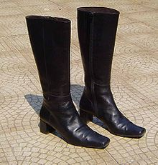
2) 35 pounds
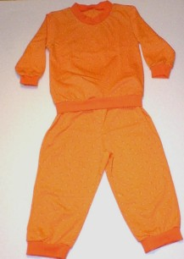
3) 75 pounds
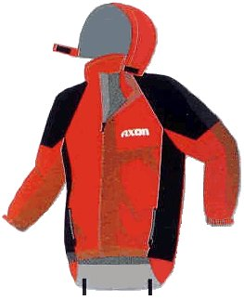
4) 99 pounds
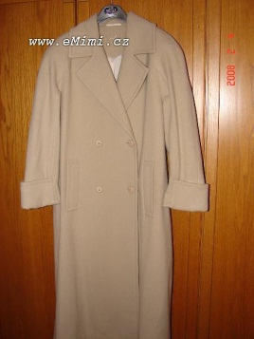
B) Complete these words into the dialogues.
thank, these, you, it´s, altogether, sweatshirt, take, can, is, it,
this, is, here, this, can, this, is
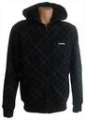 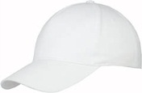 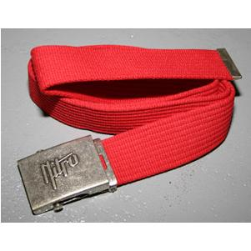
44 pounds 8 pounds 19 pounds
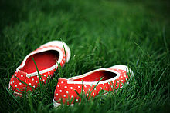
50 pounds
1) Do you like this _____?
Yes. How much _____ ______?
_________ 44 pounds.
2) _________ I help ______ ?
How much ______ _______ belt?
_______ ________ 19 pounds.
I´ll ___________ it.
3) ________ I have _____ cap and ______shoes?
Yes, that´s 58 pounds ___________
_________ you are.
________ you.
Right answers.
A) 1) How nuch are these boots?
They are 80 pounds. (These boots are 80 pounds)
2) How much are these pyjamas?
They are 35 pounds. (These pyjamas are 35 pounds)
3) How much is this jacket?
It is 75 pounds. (This jacket is 75 pounds)
4) How much is this coat?
It is 99 pounds. (This coat is 99 pounds)
B) 1) Do you like this sweatshirt?
Yes, it´s very nice. How much is it?
It´s 44 pounds.
2) Can I heĺp you?
How much is this belt?
It is 19 pounds.
I´ll take it.
3) Can I have this cap and these shoes?
Yes, that´s 58 pounds altogether.
Here you are.
Thank you.
Odkaz: použité obrázky byly staženy - obrazky.seznam

