Název školy: | ZŠ a MŠ Verneřice
Autor výukového materiálu: | Mgr. Adéla Němečková
Číslo projektu: | CZ.1.07/1.4.00/21.1526
Název: | VY_12_INOVACE_I.JJK_AJ24
Vytvořeno: | 20. 11. 2012
Vzdělávací oblast: | Jazyk a jazyková komunikace
Vzdělávací obor: | Anglický jazyk
Tematický okruh: |  | The weather
Určeno pro: | 5. ročník
Anotace: | Výukový materiál slouží ke kontrole zvládnutí probrané látky.
Metodický pokyn: | Materiál je vhodný pro samostatnou práci.
Autorem materiálu a všech jeho částí, není-li uvedeno jinak, je Mgr. Adéla Němečková.
Zdroj obrázků: Galerie MS Office.


THE WEATHER
- What weather is usually in summer?

- What weather is usually in winter?

- Write the answers:

When can we paint eggs? _________________________________
When can we go swimming? ______________________________
When can we make a snowman? ___________________________
When can we fly a kite? __________________________________
When is the Easter? _____________________________________
When is the Christmas? __________________________________

- Translate: mrak déšť mlha slunce led sníh

- Write your favourite weather:

I like when it is ……………….. because I can ……………………
I like when it is ……………….. because I can ……………………
I like when it is ……………….. because I can ……………………
I like when it is ……………….. because I can ……………………

- Write and colour – What is the weather?

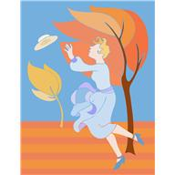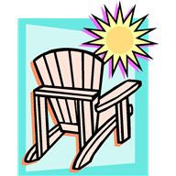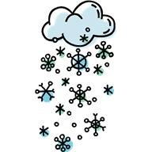

It is __________ It ___ __________ It ___ ____________ It __ ___________

THE WEATHER
- What weather is usually in summer?

It is hot, warm, sunny, …

- What weather is usually in winter?

It is cold, icy, windy, snowing, foggy, cloudy, …

- Write the answers:

When can we paint eggs? We can paint eggs at Easter.
When can we go swimming? We can go swimming in summer.
When can we make a snowman? We can make a snowman in winter.
When can we fly a kite? We can fly a kite in autumn.
When is the Easter? I tis in spring.
When is the Christmas? It is in winter.

- Translate: mrak déšť mlha slunce led sníh
cloud rain fog sun ice snow

- Write your favourite weather:

I like when it is ……………….. because I can ……………………
I like when it is ……………….. because I can ……………………
I like when it is ……………….. because I can ……………………
I like when it is ……………….. because I can ……………………

- Write: What is the weather?

It is windy. It is sunny. It is snowing. It is raining.

