



Obchodní akademie a Jazyková škola
s právem státní jazykové zkoušky Jihlava

Šablona 32

VY_32_INOVACE_169.ANJ.12

Procvičování časů – minulý prostý, průběhový, předpřítomný

Číslo projektu: | CZ.1.07/1.5.00/34.0744
Šablona: | VY_32_INOVACE
Číslo DUMU: | 169.ANJ.12
Předmět: | Anglický jazyk
Název materiálu: | Procvičování časů
Autor: | Ing. Michaela Faltusová
Formát: | Dokument Microsoft Word
Velikost: | 218 kB
Stupeň a typ vzdělávání: | SŠ – odborné vzdělávání
Licence k obrazovému materiálu: | CC BY, CC BY-SA
Datum vytvoření: | 18.4.2013
Klíčová slova: | Časy, minulý čas prostý, minulý čas průběhový, předpřítomný čas,
Anotace: | Pracovní list slouží opakování 3 časů v angličtině - minulý čas, minulý průběhový, předpřítomný. Možno použít jako test.

PRACTICE TENSES
1. Past Simple or Continuous?

What were they doing at 4 o´clock yesterday?

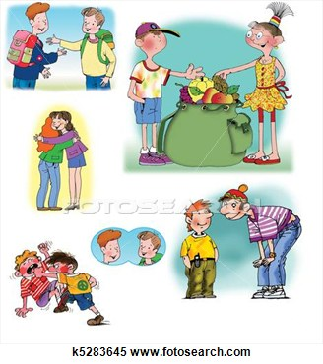
1. ____________________________________________________

2. ___________________________________________________

3. _____________________________________________________

4. ____________________________________________________

5. _____________________________________________________

6. ______________________________________________________
What__________________ (you/do), when you ______________ (see) the accident?
I _______________ (walk) along the road when I ______________ (meet) my old friend. We ___________ (stop) to talk for a few minutes.
Then a red car _________ (stop) close to us.
We ________ (talk) about a footbal match when another car __________________ (crash) into the red car.

2. Present Perfect or Past simple?

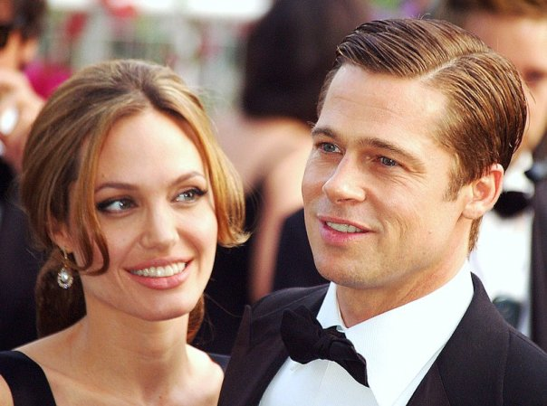http://commons.wikimedia.org/wiki/File:Angelina_Jolie_Brad_Pitt_Cannes.jpg

Today I´m talking to Angelina Jolie, the American actress, film director, and screenwriter. Tell me, how long ______________ (be) an actress?
Well, I _________ (play) with my father Jon Voight in Lookin' to Get Out in 1982, but my film career __________ (begin) later with the low-budget production Cyborg 2 in 1993.
And how many awards _________ (receive)?
I ______________ (receive) about 5 awards. The most important _____________ (be) an Academy Award in 1999.
You _________ (be) named a UNHCR Goodwill Ambassador in 2001. How many countries ___________(visit) since then?
I _______ (be) in more than 30 countries for example in Sierra Leone, Tanzania, Cambodia, Pakistan.
When _______________ (go) to Pakistan? I ________ (go) there with my husband Brad to see the country after the earthquake in 2005.
What are the best things about your job?
The travel and the people. I ________________ (travel) all over the world. And I ______________ (meet) some great people.
Well, thank you, - it __________ (be) very interesting talking to you….
1. Past Simple or Continuous?

What were they doing at 4 o´clock yesterday?

1. ____________________________________________________

2. ___________________________________________________

3. _____________________________________________________

4. ____________________________________________________

5. _____________________________________________________

6. ______________________________________________________

What_were you doing, when you saw the accident?
I was walking along the road when I met my old friend. We stopped to talk for a few minutes.
Then a red car stopped close to us.
We were talking about a footbal match when another car crashed into the red car.

2. Present Perfect or Past simple?

http://commons.wikimedia.org/wiki/File:Angelina_Jolie_Brad_Pitt_Cannes.jpg

Today I´m talking to Angelina Jolie, the American actress, film director, and screenwriter. Tell me, how long have you been (be) an actress?
Well, I played (play) with my father Jon Voight in Lookin' to Get Out in 1982, but my film career began_ (begin) later with the low-budget production Cyborg 2 in 1993.
And how many awards have you received (receive)?
I have received (receive) about 5 awards. The most important was (be) an Academy Award in 1999.
You were (be) named a UNHCR Goodwill Ambassador in 2001. How many countries have you visited (visit) since then?
I have been (be) in more than 30 countries for example in Sierra Leone, Tanzania, Cambodia, Pakistan.
When did you go (go) to Pakistan? I went (go) there with my husband Brad to see the country after the earthquake in 2005.
What are the best things about your job?
The travel and the people. I have travelled (travel) all over the world. And I have met (meet) some great people.
Well, thank you, - it has been (be) very interesting talking to you….

Všechny uveřejněné odkazy dostupné pod licencí Creative Commons.
Obrázek str. 3, 4 - http://commons.wikimedia.org/wiki/File:Angelina_Jolie_Brad_Pitt_Cannes.jpg
dostupný pod licencí Public Domain.
Autor: Georges Biard

