Název školy: Základní škola Městec Králové

Autor: Mgr. Marcela Kloučková

Název: VY_32_INOVACE_19_Aj6

Téma: Přídavná jména, příslovce

Číslo projektu: CZ.1.07/1.4.00/21.2313

Anotace: Tento pracovní list obsahuje úkoly zaměřené na tvoření příslovcí. Dále jsou zde cvičení, která ověřují, zda žáci rozumí rozdílu v užití příslovcí a přídavných jmen v anglickém jazyce.

Datum: 15. 9. 2012

Adverbs and Adjectives – Worksheet

Find 12 adjectives in the word search puzzle. Write the adverbs.
F | N | G | V | F | Z | E | U | N | Q  bad – badly
A | K | O | W | Y | A | I | S | I | U
S | O | O | E | H | R | T | U | C | I
T | U | D | H | I | A | U | A | E | B
F | A | S | T | C | O | R | L | P | A
G | E | A | S | Y | M | P | D | L | D
C | A | R | E | F | U | L | E | B | O
R | U | A | S | H | E | A | V | Y | O
N | O | R | M | A | L | N | E | I | G
M | I | S | E | R | A | B | L | E | W

- Choose the correct word to complete the sentences.
This exercise is very hard / hardly.
Peter can speak Spanish good / well.
Mary is a good / well singer.
This box is very heavy / heavily.
He doesn’t work slow / slowly.
I think English is an easy / easily language.
My parents learn English easy / easily.
We heard a loud / loudly noise.
My father drives fast / fastly.

- Correct the mistakes.
He is a badly singer. bad
I can’t speak loud.
My best friend is a well painter. He paints good.
Mrs Smith is a quietly lady. She speaks quiet.
They did their homework correct.
My uncle doesn’t drive fastly.

- Write sentences about yourself. Use these adjectives and adverbs.
quiet quietly well good bad badly

I’m not a quiet person.

- A) Write the adverbs.
loud - quick – heavy -
good – quiet - slow -

B) Use adverbs in exercise 5A and these photographs to make sentences.
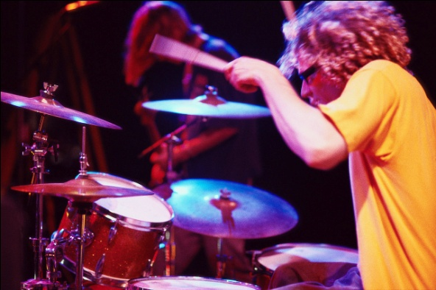
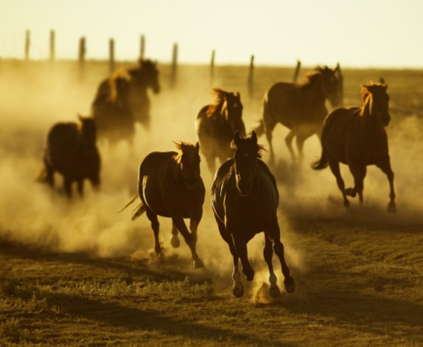


[1] [2] [3]


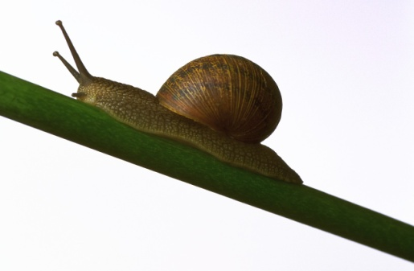

[4] [5] [6]

1) They’re running quickly. 4)
2) 5)
3) 6)

- Complete the crossword puzzle.

RYCHLE
SMUTNĚ
TĚŽCE
DOBŘE
OPATRNĚ
ŠPATNĚ
POMALU

ANSWER KEY

Adverbs and Adjectives – Worksheet

Find 12 adjectives in the word search puzzle. Write the adverbs.
bad – badly
fast- fast
good – well
easy – easily
heavy – heavily
nice – nicely
miserable – miserably
hard – hard
normal – normally
usual – usually
fast –fast
careful - carefully

F | N | G | V | F | Z | E | U | N | Q
A | K | O | W | Y | A | I | S | I | U
S | O | O | E | H | R | T | U | C | I
T | U | D | H | I | A | U | A | E | B
F | A | S | T | C | O | R | L | P | A
G | E | A | S | Y | M | P | D | L | D
C | A | R | E | F | U | L | E | B | O
R | U | A | S | H | E | A | V | Y | O
N | O | R | M | A | L | N | E | I | G
M | I | S | E | R | A | B | L | E | W

- Choose the correct word to complete the sentences.
This exercise is very hard / hardly.
Peter can speak Spanish good / well.
Mary is a good / well singer.
This box is very heavy / heavily.
He doesn’t work slow / slowly.
I think English is an easy / easily language.
My parents learn English easy / easily.
We heard a loud / loudly noise.
My father drives fast / fastly.

- Correct the mistakes.
He is a badly singer. bad
I can’t speak loud. loudly
My best friend is a well painter. He paints good. good, well
Mrs Smith is a quietly lady. She speaks quiet. quiet, quietly
They did their homework correct. correctly
My uncle doesn’t drive fastly. fast

- Write sentences about yourself. Use these adjectives and adverbs.
quiet quietly well good bad badly

I’m not a quiet person.
Pupils’ own answers.

- A) Write the adverbs.
loud - loudly quick – quickly heavy - heavily
good – well quiet - quietly slow - slowly

B) Use adverbs in exercise 5A and these photographs to make sentences.

[1] [2] [3]

[4] [5] [6]

- They’re running quickly. 4) It’s raining heavily.
- He’s playing football well. 5) It’s moving slowly.
- He’s playing the drums loudly. 6) She’s talking quietly.

- Complete the crossword puzzle.

 |  |  |  | F | A | S | T |  |  |  |  | RYCHLE
 |  |  | S | A | D | L | Y |  |  |  |  | SMUTNĚ
 |  | H | E | A | V | I | L | Y |  |  |  | TĚŽCE
 |  |  |  | W | E | L | L |  |  |  |  | DOBŘE
 |  |  | C | A | R | E | F | U | L | L | Y | OPATRNĚ
 |  |  |  |  | B | A | D | L | Y |  |  | ŠPATNĚ
 |  |  |  |  | S | L | O | W | L | Y |  | POMALU

Zdroje

[1] Koně. Office.com [online]. 2013 [cit. 2013-04-18]. Dostupné z: http://office.microsoft.com/cs-cz/images/results.aspx?qu=kon%C4%9B&ex=1#ai:MP900431746|
[2] Fotbal. Office.com [online]. 2013 [cit. 2013-04-18]. Dostupné z http://office.microsoft.com/cs-cz/images/results.aspx?qu=fotbal&ex=1#ai:MP900448584|mt:2|
[3] Bicí. Office.com [online]. 2013 [cit. 2013-04-18]. Dostupné z http://office.microsoft.com/cs-cz/images/results.aspx?qu=bubny&ex=1#ai:MP900407246|
[4] Déšť. Office.com [online]. 2013 [cit. 2013-04-18]. Dostupné z http://office.microsoft.com/cs-cz/images/results.aspx?qu=d%C3%A9%C5%A1%C5%A5&ex=1#ai:MP900403192|
[5] Hlemýžď. Office.com [online]. 2013 [cit. 2013-04-18]. Dostupné z http://office.microsoft.com/cs-cz/images/results.aspx?qu=helm%C3%BD%C5%BE%C4%8F&ex=1#ai:MP900406501|mt:2|
[6] Mluvit. Office.com [online]. 2013 [cit. 2013-04-18]. Dostupné z http://office.microsoft.com/cs-cz/images/results.aspx?qu=mluvit&ex=1#ai:MP900402594|

