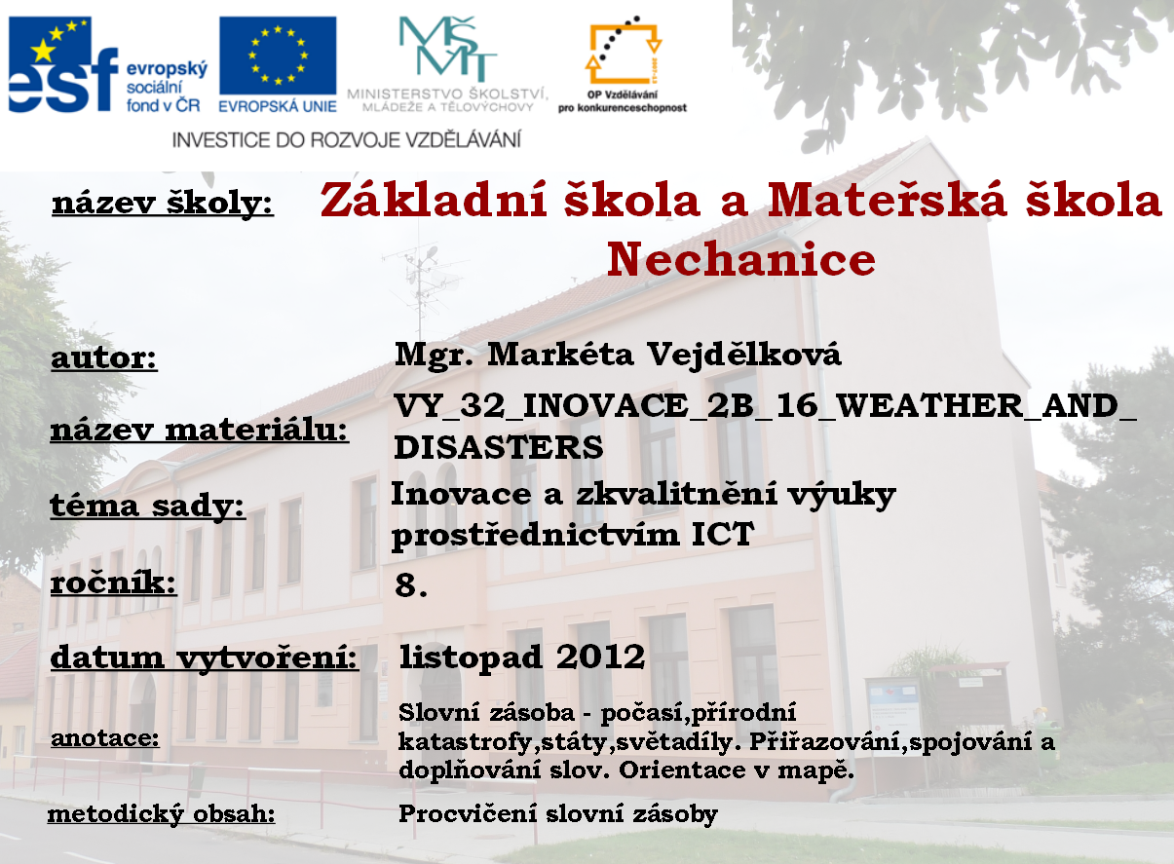

- Complete the parts of the words together.
BLIZZ | FOG | ERATURE | NADO
SNOW | THUN | GY | LIGHT
TEMP | DER | SUN | CANO
TOR | ICANE | ARD | CLOU
QUAKE | FLAKE | SET | HURR
SUN | DY | VOL | EARTH

Write the complete words here.:

- For each letter of „snowflake“ try to find words which are connected with the topic weather or natural disasters. Think of as many as you can.

S
N
O
W
F
L
A
K
E

- What is the weather forecast today?

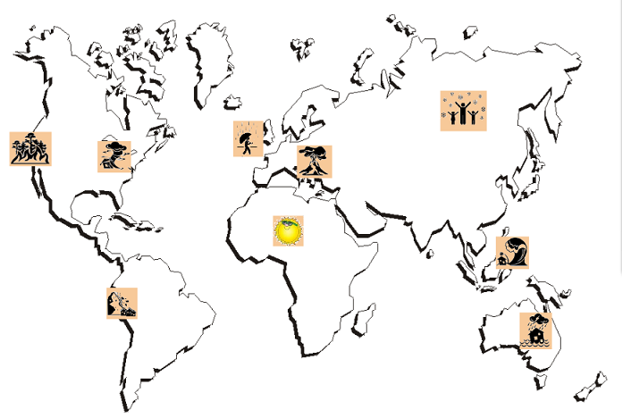

In North America there is a ____________________ in the West.

In Australia there are __________________ .

In London is ___________________ .

In South America there is an _________________________ .

In Russia is ________________________ .

In Africa is ________________________ .

In North America there is a ____________________ in the East.

In Japan there is a _________________________ .

In Italy there is a _________________________ .

CITACE:

Illustration - set silhouette icons of natural disaster. In: 123rf [online]. 2013 [cit. 2013-05-22]. Dostupné z: https://www.google.cz/search?q=http://www.123rf.com/photo_7558360_set-silhouette-icons-of-natural-disaster.html&client=firefox-a&hs=7Nb&rls=org.mozilla:en-US:official&source=lnms&tbm=isch&sa=X&ei=uySdUauRJ4fPsga4uYDQBw&ved=0CAoQ_AUoAQ&biw=1280&bih=671#imgrc=AjK2GnrX7uQhGM%3A%3Bb6aTZFJCI3qM-M%3Bhttp%253A%252F%252Fus.123rf.com%252F400wm%252F400%252F400%252Fprint2d%252Fprint2d1008%252Fprint2d100800017%252F7558360-set-silhouette-icons-of-natural-disaster.jpg%3Bhttp%253A%252F%252Fwww.123rf.com%252Fph

Free printable maps. In: Free printable maps [online]. 2013 [cit. 2013-05-22]. Dostupné z: http://www.google.cz/search?q=earth+map&client=firefox-a&hs=ElG&rls=org.mozilla:en-US:official&hl=cs&source=lnms&tbm=isch&sa=X&ei=USWdUfX9HIjesgbEp4GQBw&ved=0CAoQ_AUoAQ&biw=1280&bih=671#q=earth+map&client=firefox-a&hs=qQb&rls=org.mozilla:en-US:official&hl=cs&tbm=isch&source=lnt&tbs=itp:lineart&sa=X&ei=ZCWdUYT7F470sgbnoIHABg&ved=0CEEQpwUoBA&bav=on.2,or.r_qf.&bvm=bv.46751780,d.Yms&fp=85a194181548b5a0&biw=1280&bih=671&imgrc=_5Fc3Y8xLWcAGM%3A%3BT3TGkrDIjK60gM%3Bhttp%253A%252F%252Fwww.clker.com%252Fc

Weather flashcard. In: Eslprintables [online]. 2013 [cit. 2013-05-22]. Dostupné z: https://www.google.cz/search?q=http://www.eslprintables.com.es/previewprintables/2011/feb/28/thumb102281243323194.jpg&client=firefox-a&hs=1Wb&rls=org.mozilla:en-US:official&source=lnms&tbm=isch&sa=X&ei=4yadUc3NCJGRswbc-IGoBw&ved=0CAoQ_AUoAQ&biw=1280&bih=671#imgrc=ciRsq1dAmAXQyM%3A%3B4nKHbvqVEp-MFM%3Bhttp%253A%252F%252Fwww.eslprintables.com.es%252Fpreviewprintables%252F2011%252Ffeb%252F28%252Fthumb102281243323194.jpg%3Bhttp%253A%252F%252Fwww.eslprintables.com%252Fvocabulary_worksheets%252Fthe_wea

Zdroje obrazek kliparty na mapu
http://www.123rf.com/photo_17968699_weather-climate-atmosphere-environment-meteorology-season-people-man-stick-figure-pictogram-icon.html

http://www.123rf.com/photo_7558360_set-silhouette-icons-of-natural-disaster.html

map
https://www.google.cz/search?q=earth+map&client=firefox-a&rls=org.mozilla:en-US:official&hl=cs&source=lnms&tbm=isch&sa=X&ei=JIiXUcriL8SdtQblj4DQDA&ved=0CAoQ_AUoAQ&biw=1280&bih=671#q=earth+map&client=firefox-a&rls=org.mozilla:en-US:official&hl=cs&tbm=isch&source=lnt&tbs=ic:gray&sa=X&ei=N4iXUZHZAY-VswaQ9YGgDA&ved=0CC0QpwUoAg&bav=on.2,or.r_qf.&bvm=bv.46751780,d.Yms&fp=d081e036cf1aaac1&biw=1280&bih=671&imgrc=uFqXn_SPODHieM%3A%3B8uPecGyYXVwcVM%3Bhttp%253A%252F%252Fwww.wpmap.org%252Fwp-content%252Fuploads%252F2011%252F05%252Fworld-map-outline.png%3Bhttp%253A%252F%252Fwww.wpmap.org%252Fcategory%252Fworld-maps%252F%3B1357%3B628

http://www.free-printable-maps.com/free-printable-world-maps.htm

