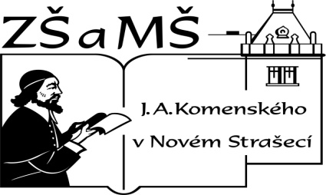Základní škola a mateřská škola J. A. Komenského
v Novém Strašecí
Komenského nám. 209, 271 01 Nové Strašecí
tel. 311 240 401, 311 240 400, email: zsnovstra@email.cz

ČÍSLO PROJEKTU: 1.4 OP VK
NÁZEV: VY_22_INOVACE_02
AUTOR: Mgr. Dana Grillová
ŠKOLNÍ ROK: 2011-2012
ROČNÍK: 4

VZDĚLÁVACÍ OBLAST: Jazyk a jazyková komunikace
VZDĚLÁVACÍ OBOR: Cizí jazyk
TÉMATICKÝ OKRUH: Receptivní, produktivní a interaktivní řečové dovednosti
TÉMA: Shopping
ANOTACE: Žák si osvojí jazykové prostředky vztahující se k uvedenému tématu, rozumí myšlenkám čtenému textu a umí vyjádřit jeho obsah, rozšiřuje a zdokonaluje si gramatické, konverzační i písemné znalosti. Je schopen popisovat a tvořit otázky.
KLÍČOVÁ SLOVA: shopping, must, do you have to go, can.



Shopping
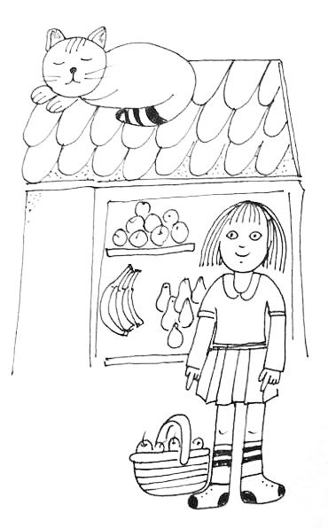I am Peggy. My mother can’t go shopping today. I am shopping for her. I live in Dower Street. There are many shops in this street. I must buy milk and bread in the supermarket. I can buy tea and cocoa in the supermarket, too. Then I need to buy some fruit. There are lots of apples, bananas, lemons and oranges in the shop window. There are pears, too. My mother wants them, too. So I can take apples, oranges and pears.

Shop assistant: Good afternoon. What can I do for you?
Lucy: Some apples, oranges and pears, please.
Shop assistant: The oranges are very good today. Look, they are fresh and orange.
Lucy: Yes, they are fine. Five apples and pears, please.
Shop assistant: Is that all?
Lucy: Yes, thank you.
Shop assistant: Thank you. Bye.

- Přečti a přelož.

- Popiš obrázek:
a girl (name, how old, clothes …………)
a supermarket (big, colour ………)
a cat (name, head, body ……………)

- Vyjádři otázky slova must opisem.
I must go to school at seven. – Do you have to go to school at seven?
She must go to school at seven. – Does she have to go to school at seven?

We must take this yellow book.
Peggy must go alone.
She must take some things to her mother.
He is going by bus.
He is returning on Sunday.

- Předveď rozhovor mezi nakupujícím a prodavačem
A: Good morning. What can ……… do ……… you?
B: Some ………, please.
A: Look, they ……… fine. Is that all?
B: No, it ………. Give me a ………, please.
A: Yes, ……… you are.
B: Thank you very much.
A: Goodbye. Have a nice day.
B: Good ……….

- Doplň vhodně rozhovor
Shop assistant: Good afternoon. What can I ……… for ………?
Mark: Some tomatoes, ……….
Shop assistant: The tomatoes are very good today. Look, ……… are nice and……
Mark: Yes, ……… are fine. And some ………, please.
Shop assistant: Is that ………?
Lucy: Yes, ……… you.
Shop assistant: Thank ……….

- Odpověz podle textu,vymysli další otázky.
What does Peggy have to do for her mother today? Where can Peggy buy milk and bread? Can she buy fruit in the supermarket? Is her shopping bag full?

- Ptej se.
- You can stay at school. (Peter)
- Can Peter stay at school, too?
You must sit here. (dad)
You can read this book. (mum)
We must help mum. (father)
They can go shopping. (aunt)
He can stop here. (I)
I must read this book. (my friend)
I can read that book. (my dog)

- Rým a hra.
Jeden žák řekne rým. Další žák opakuje rým se svým jménem a jde k prvnímu, kde utváří kruh. V kruhu zpívají a točí se všechny děti. Končíme rýmem: … all children dance in a place, all children sing in a ring

I dance in a place,
I sing in a ring.
Peter dances in a place,
Peter sings in a ring.
Jane dances ……………………
Jane sings …………………
Lucy ……………………
All children dance in a place, ……………………
All children sing in a ring ……………………

References (použitá literatura)
Obrázek a text vytvořil autor.

