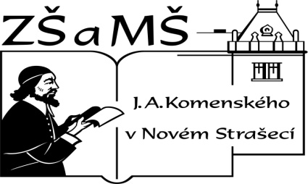Základní škola a mateřská škola J. A. Komenského
v Novém Strašecí
Komenského nám. 209, 271 01 Nové Strašecí
tel. 311 240 401, 311 240 400, email: zsnovstra@email.cz

ČÍSLO PROJEKTU: 1.4 OP VK
NÁZEV: VY_22_INOVACE_03
AUTOR: Mgr. Dana Grillová
ŠKOLNÍ ROK: 2011-2012
ROČNÍK: 4

VZDĚLÁVACÍ OBLAST: Jazyk a jazyková komunikace
VZDĚLÁVACÍ OBOR: Cizí jazyk
TÉMATICKÝ OKRUH: Receptivní a produktivní řečové dovednosti
TÉMA: In the morning
ANOTACE: Žák si osvojí jazykové prostředky vztahující se k uvedenému tématu, rozumí myšlenkám čtenému textu a umí vyjádřit jeho obsah, rozšiřuje a zdokonaluje si gramatické, konverzační i písemné znalosti. Je schopen popisovat, vytvářet otázky a odpovídat podle skutečnosti.
KLÍČOVÁ SLOVA: in the morning, Sundays, like, don’t like, doesn’t like, is making.



In the morning
It is seven o’clock, Monday morning. Peter, his two sisters and their parents are at home. Peter’s sisters are Lucy and Betty. Peter is in his bedroom. He is getting up and getting dressing. He is thinking about his clothes - he is putting his jeans and sweater on. Is Lucy in her bedroom? No, she isn’t. She is in the bathroom. She is washing her face and hands in cold water. But where is their little sister? Lucy’s little sister is in her bed. She is not well, she is sad. Mr Novak is in the living room. What is he doing here? He is sitting at the table and reading his paper. Mrs Novak is in the kitchen and she is making breakfast for her family. The children must go to school and their parents to work. And what is doing their dog Elsa?

- Dopiš příběh o psovi z rodiny Novákových.

- Odpověz podle textu.
Is Mrs Novak making breakfast for her children?
Who is making it?
Where is she making it?
What is Mr Novak doing?
Is he reading in his bedroom?
What is Peter doing?
What is Lucy doing?
- Vymysli další otázky.

- Vyber jeden obrázek a popiš. Použij tyto výrazy.
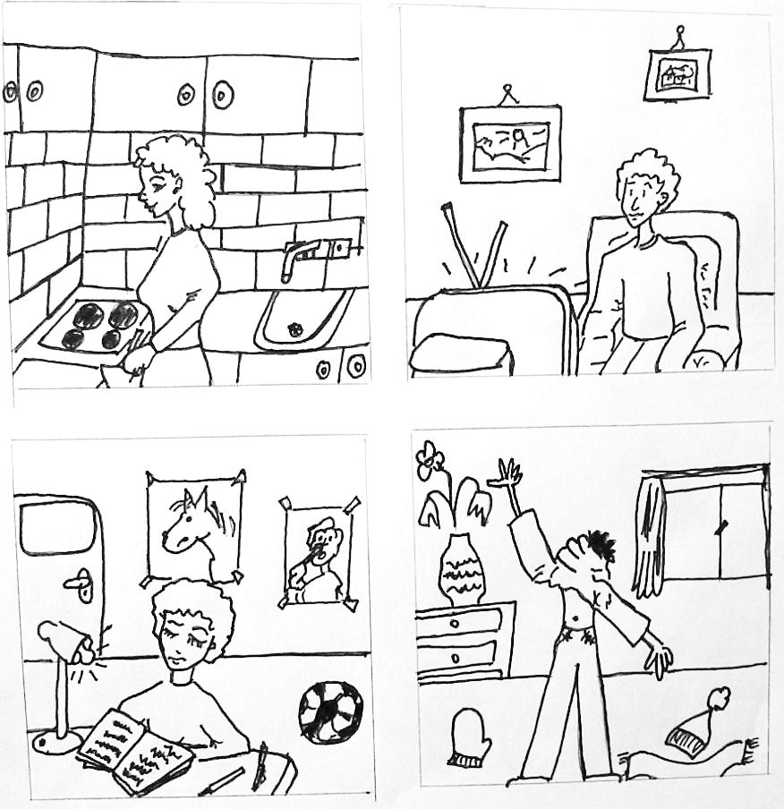
girl - boy, name, … is wearing, … is doing, he (she) is in the kitchen (bedroom, bathroom, living room), he (she) is …years old, …
- Odpověz podle skutečnosti
Are you a small boy (girl)?
Are you busy in the morning?
Are you often late in the morning?
Are you at school on Sundays?
Where are you on Sundays and what are you doing?

- I like ------ I don’t like ……… He (she, it) doesn’t like. Podle obrázku řekni, co má dívka ráda a co nemá ráda.
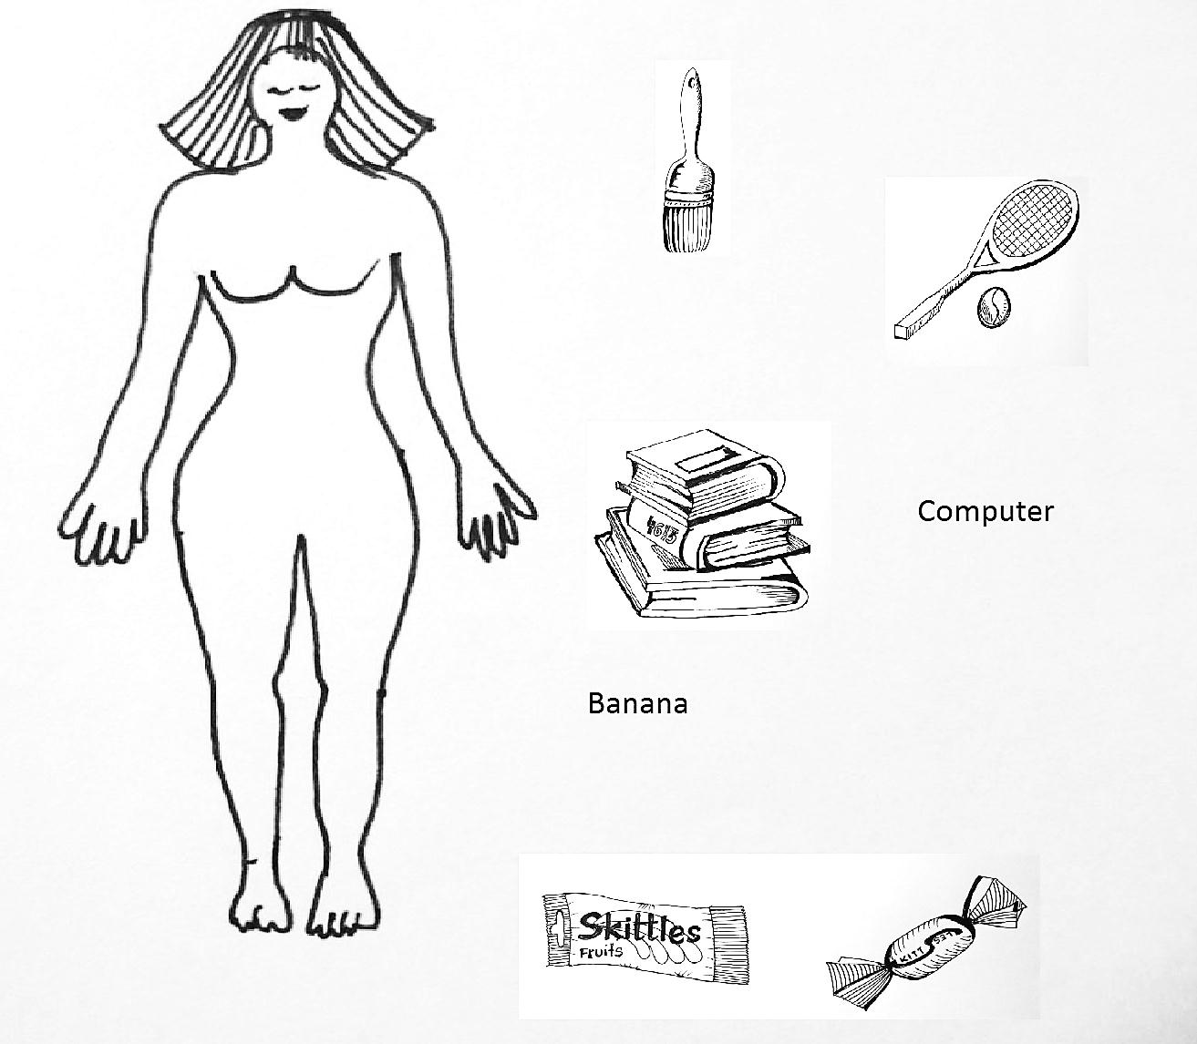
- Z písmen u správných odpovědí sestav tajenku.
- Peggy likes eating Skittles. (CH)
Peggy like eating Skittles. (V)

- Peggy don’t like playing games on computer.(E)
Peggy doesn’t like playing games on computer.(I)

- Peggy like reading a book.(R)
Peggy likes reading a book.(L)

- Peggy likes painting pictures.(G)
Peggy doesn’t like painting pictures.(D)

- Peggy likes eating bananas.(R)
Peggy like eating bananas.(O)

- Peggy likes playing tennis.(O)
Peggy doesn’t like playing tennis.(E)

- Peggy doesn’t like eating sweets.(N)
Peggy don’t like eating sweets.(D)

- Ze zbylých písmen utvoř další tajenku, ve slově velmi chybí jedno písmeno - doplň.

References (použitá literatura)
Obrázek a text vytvořil autor.

