
Základní škola a mateřská škola J. A. Komenského
v Novém Strašecí
Komenského nám. 209, 271 01 Nové Strašecí
tel. 311 240 401, 311 240 400, email: zsnovstra@email.cz

ČÍSLO PROJEKTU: 1.4 OP VK
NÁZEV: VY_22_INOVACE_06
AUTOR: Mgr. Dana Grillová
ŠKOLNÍ ROK: 2011-2012
ROČNÍK: 4

VZDĚLÁVACÍ OBLAST: Jazyk a jazyková komunikace
VZDĚLÁVACÍ OBOR: Cizí jazyk
TÉMATICKÝ OKRUH: Receptivní a produktivní řečové dovednosti
TÉMA: At the swimming pool
ANOTACE: Žák si osvojí jazykové prostředky vztahující se k uvedenému tématu, rozumí myšlenkám čtenému textu a umí vyjádřit jeho obsah, rozšiřuje a zdokonaluje si gramatické, konverzační i písemné znalosti. Je schopen napsat jednoduchý souvislý text.
KLÍČOVÁ SLOVA: swimming pool, swimmer, woman, women, man, men..



At the swimming pool
It is a fine summer day. Is the sun shining?- the … is shi… It is a very warm day. Are Peter and his friend cycling to the swimming pool? T… are cycling to the swimming pool. ‘Look, there are a lot of people in the swimming pool.’ The boys are OK. A lot of people are swimming in the pool. About twenty or thirty. Lots of people are sitting in the sun. Some are sitting under the trees on the lawn. One end of the pool is for good swimmers. There are no bad swimmers there. About fifteen children are in the water. Some of them can’t swim. Two little girls are learning to swim. ‘Can you swim, girls?’ ‘No, ……… We are learning to ………, but it ……… easy for us.’

- Dokonči příběh.

- Odpověz podle textu.
What are Tom and his friend doing? Are there many people in the pool? About how many people are there? Are all the people swimming? What are the two little girls doing?

- Odpověz podle skutečnosti.
What can you do on a fine summer day? Are you a good swimmer? Can only good swimmers attend the swimming pool? Is swimming easy for very small children? Can you swim in rivers, lakes and sea , too?

- Popiš obrázek a vyber podle obrázku.
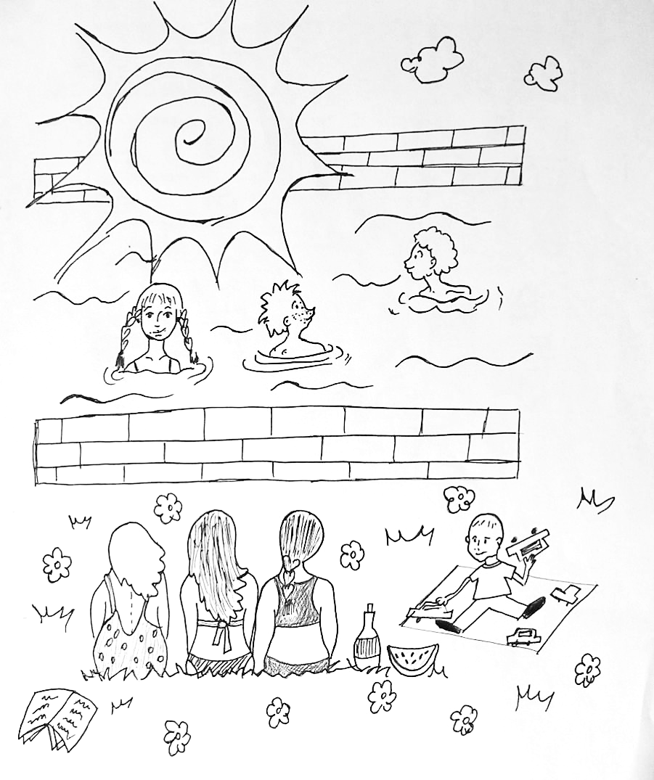
- The people are:
- In the swimming pool
- At the sea
- In the mountains

- It is:
- Winter
- Autumn
- Summer
- The sun:
- Is shining
- Is not in the sky
- Is in the sky
- There are:
- Three men and one woman
- Two boys and one girl
- Nine people
- There are:
- Two boys in the water
- Two boys and one girl in the water
- Four people in the water
- There are:
- Three women on the grass
- Three men on the grass
- Five people on the grass

- Odpověz:
Where is the baby?
What is the baby doing?

- Najdi slova: woman, men, women, man. Z výraznějších písmen sestav tajenku.
P | M | W | O | M | A | N | K | L | O | W | S
A | C | S | P | A | E | R | T | F | W | I | L
J | O | R | Z | N | S | Z | L | O | O | O | K
A | W | C | F | P | L | N | P | R | M | B | A
S | L | E | M | E | M | E | N | P | E | Q | E
A | C | B | D | I | J | V | W | Y | N | I | Z
References (použitá literatura)
Obrázek a text vytvořil autor.

