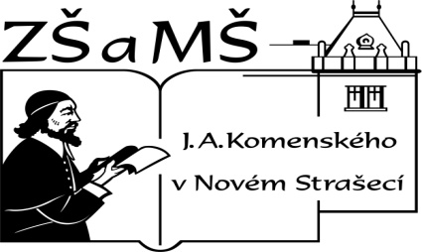
Základní škola a mateřská škola J. A. Komenského
v Novém Strašecí
Komenského nám. 209, 271 01 Nové Strašecí
tel. 311 240 401, 311 240 400, email: zsnovstra@email.cz

ČÍSLO PROJEKTU: 1.4 OP VK
NÁZEV: VY_22_INOVACE_09
AUTOR: Mgr. Dana Grillová
ŠKOLNÍ ROK: 2011-2012
ROČNÍK: 4

VZDĚLÁVACÍ OBLAST: Jazyk a jazyková komunikace
VZDĚLÁVACÍ OBOR: Cizí jazyk
TÉMATICKÝ OKRUH: Receptivní, produktivní a interaktivní řečové dovednosti
TÉMA: Late again
ANOTACE: Žák si osvojí jazykové prostředky vztahující se k uvedenému tématu, rozumí myšlenkám čtenému textu a umí vyjádřit jeho obsah, rozšiřuje a zdokonaluje si gramatické, konverzační i písemné znalosti. Je schopen vyjádřit jednoduchý popis písemnou formou.
KLÍČOVÁ SLOVA: where, who, what, when, what time.



Late again!
It is Monday today. The boys and girls are at school in the morning. Not all the children are in the classroom. Some boys are in the classroom, some are not. Sixteen boys are in the classroom, six boys are in the garden. Five girls are in the garden, too. This school garden is very large. There are a lot of flowers, a green lawn and big trees. It is nine o’clock. The teacher, Miss Green is in the classroom. She is in the classroom at nine every day. All the girls are in the classroom at nine o’clock, too. Not all the boys are there. One boy is often late. He is late again this morning. His name is Jim.

- Odpověz podle textu.
Where are the children in the morning?
Are all the girls in the classroom at nine?
Are all the boys there?
Who is not at school?
Who is often late?

- Užij zkrácené tvary.
Vzor: The boys are not late. The boys aren’t late.
My friends are not in the park. Some children are not late. Three girls are not here. The children are not in the park. Some boys are not good at tennis.

- Povídej si.
A: Where are you at ten?
B: At school.
(at six – at home, at ten – in the park, at four – in the swimming pool………)

- Vybarvi a dokresli obrázek.
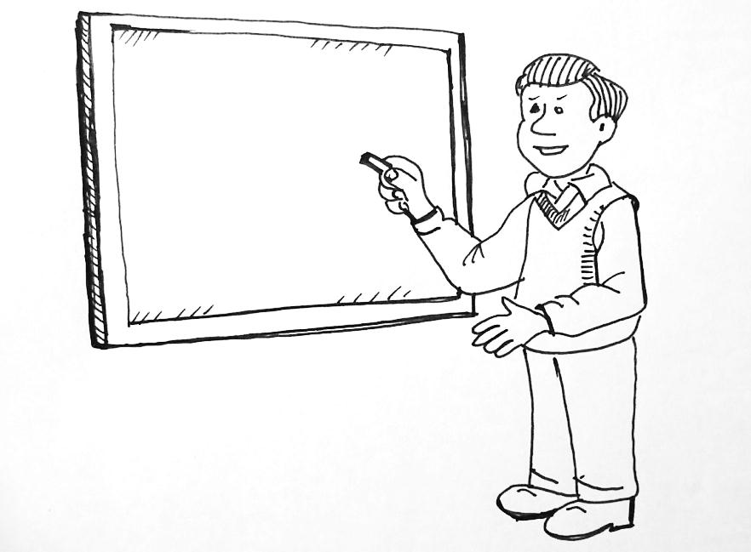
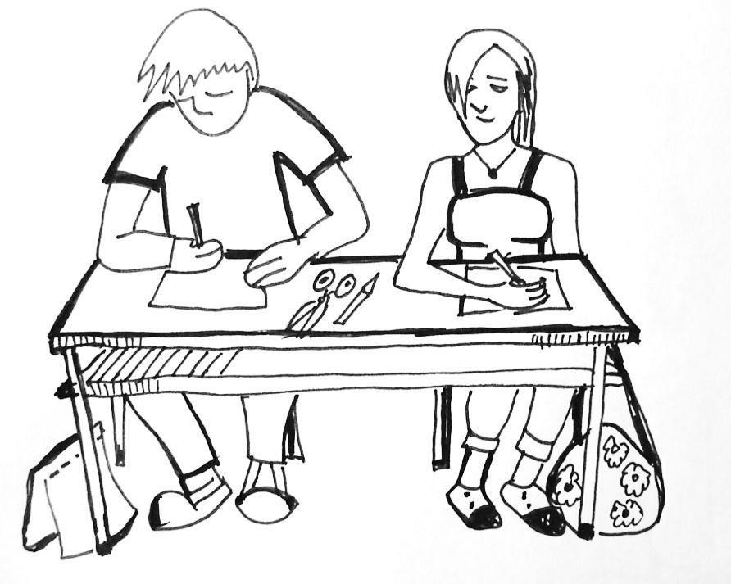
School, teacher, pupil, desk, blackboard, chalk, class, pencil, pen, sponge, textbook, exercise book, paper, rubber, scissors, schoolbag

- Tvoř otázky se slovy podle obrázku ze cvičení 4, dokresli.
Where is the exercise book?
Who is standing at the blackboard?
When is the boy at school?
What time is ……………?
What is on the table?
What is under the table?
What is opposite the ……………?

- Napiš několik vět o obrázku.

References (použitá literatura)
Obrázky a text vytvořil autor.

