What´s this? Is it a………?
Yes, it is./No, it isn´t.

Is it a foot?________________________

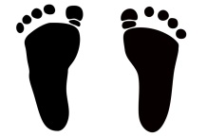

Is it a hand?___________________________

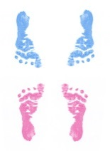

Is it a leg?__________________________

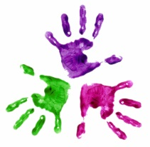

Is it an arm?__________________________

Is it a head?__________________________

Zdroje:

www.office.microsoft.com.

