Zakroužkuj správnou odpověď:
- Is it a dog? Yes, it is.
No, it isn´t.
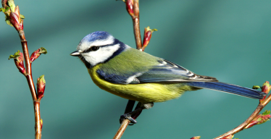
- Is it a bird? Yes, it is.
No, it isn´t.

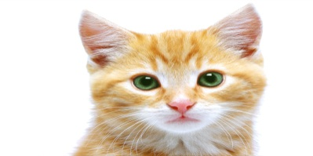
- Is it a cat? Yes, it is.
No, it isn´t.


- Is it a fish? Yes, it is.
No, it isn´t.

- Is it a mouse? Yes, it is.
No, it isn´t.

Zdroje: (http://www.office.microsoft.com/)

