Přečti slova a obrázky vybarvi:

- This bag is brown.

- This book is blue.

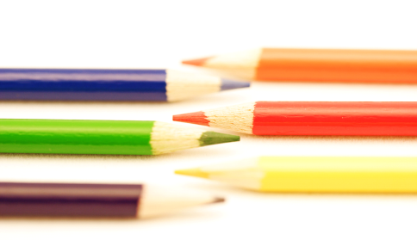
- These pencils are red.

- These pens are green.

Zdroje: (http://www.office.microsoft.com/)

